

NBCC Pharmacy Sequence Diagrams  
2025 Programmer Analyst Team  
March 18, 2025

CONTENTS

US1 4

USER SIGNUP SSD 4

US2 5

DELETE USER SSD 5

US3 6

USER LOGIN SSD 6

RESET PASSWORD SSD 7

US4 8

CREATE ORDER SSD 9

US5 9

IMAGE UPLOAD ON ADD ORDER PAGE 10

IMAGE UPLOAD ON AMEND ORDER PAGE 10

IMAGE UPLOAD ON VERIFICATION PAGE 11

US7 12

VERIFY ORDER SSD 13

US8 13

AMEND ORDER 14

US9 14

PRINT DISPENSING LABEL SSD 15

US10 16

RE-PRINT DISPENSING LABEL SSD 16

US11 17

INACTIVITY SSD 17

US12 18

VIEW ORDERS 18

ORDERS TO VERIFY 19

US13 20

ADD DRUG 20

US14 21

VIEW DRUGS 21

US15 22

DELETE DRUG(S) 22

US16 23

EDIT DRUG 23

US17 24

ADD PHYSICIAN 24

US18 25

VIEW PHYSICIANS 25

US19 26

DELETE PHYSICIAN(S) 26

US20 27

EDIT PHYSICIAN 27

US21 28

ADD PATIENT 28

US22 29

VIEW PATIENTS 29

US23 30

DELETE PATIENT(S) 30

US24 31

EDIT PATIENT 31

DOCUMENT REVISIONS 32

DOCUMENT REVIEW 33

# US1

## USER SIGNUP SSD

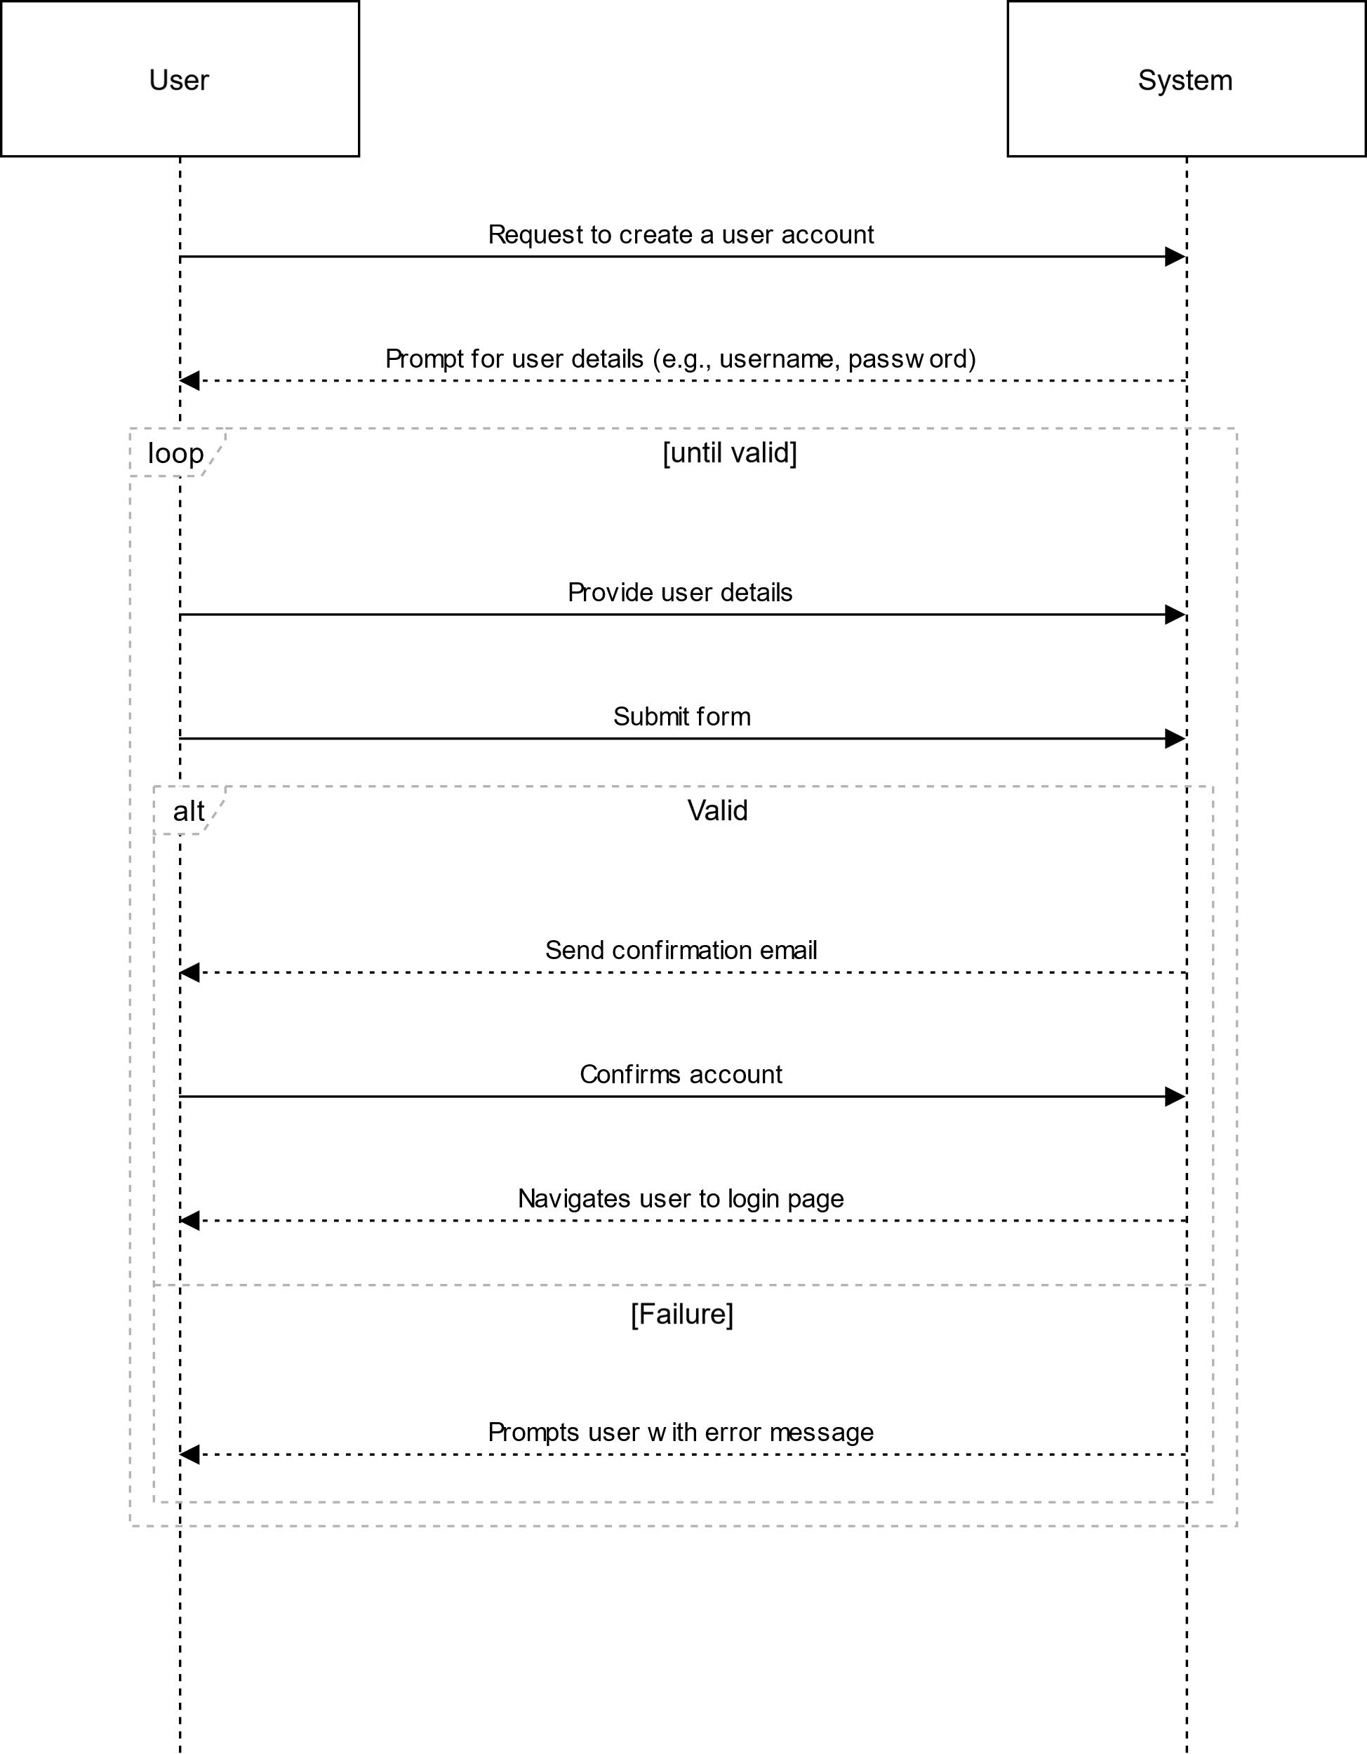

# US2

## DELETE USER SSD

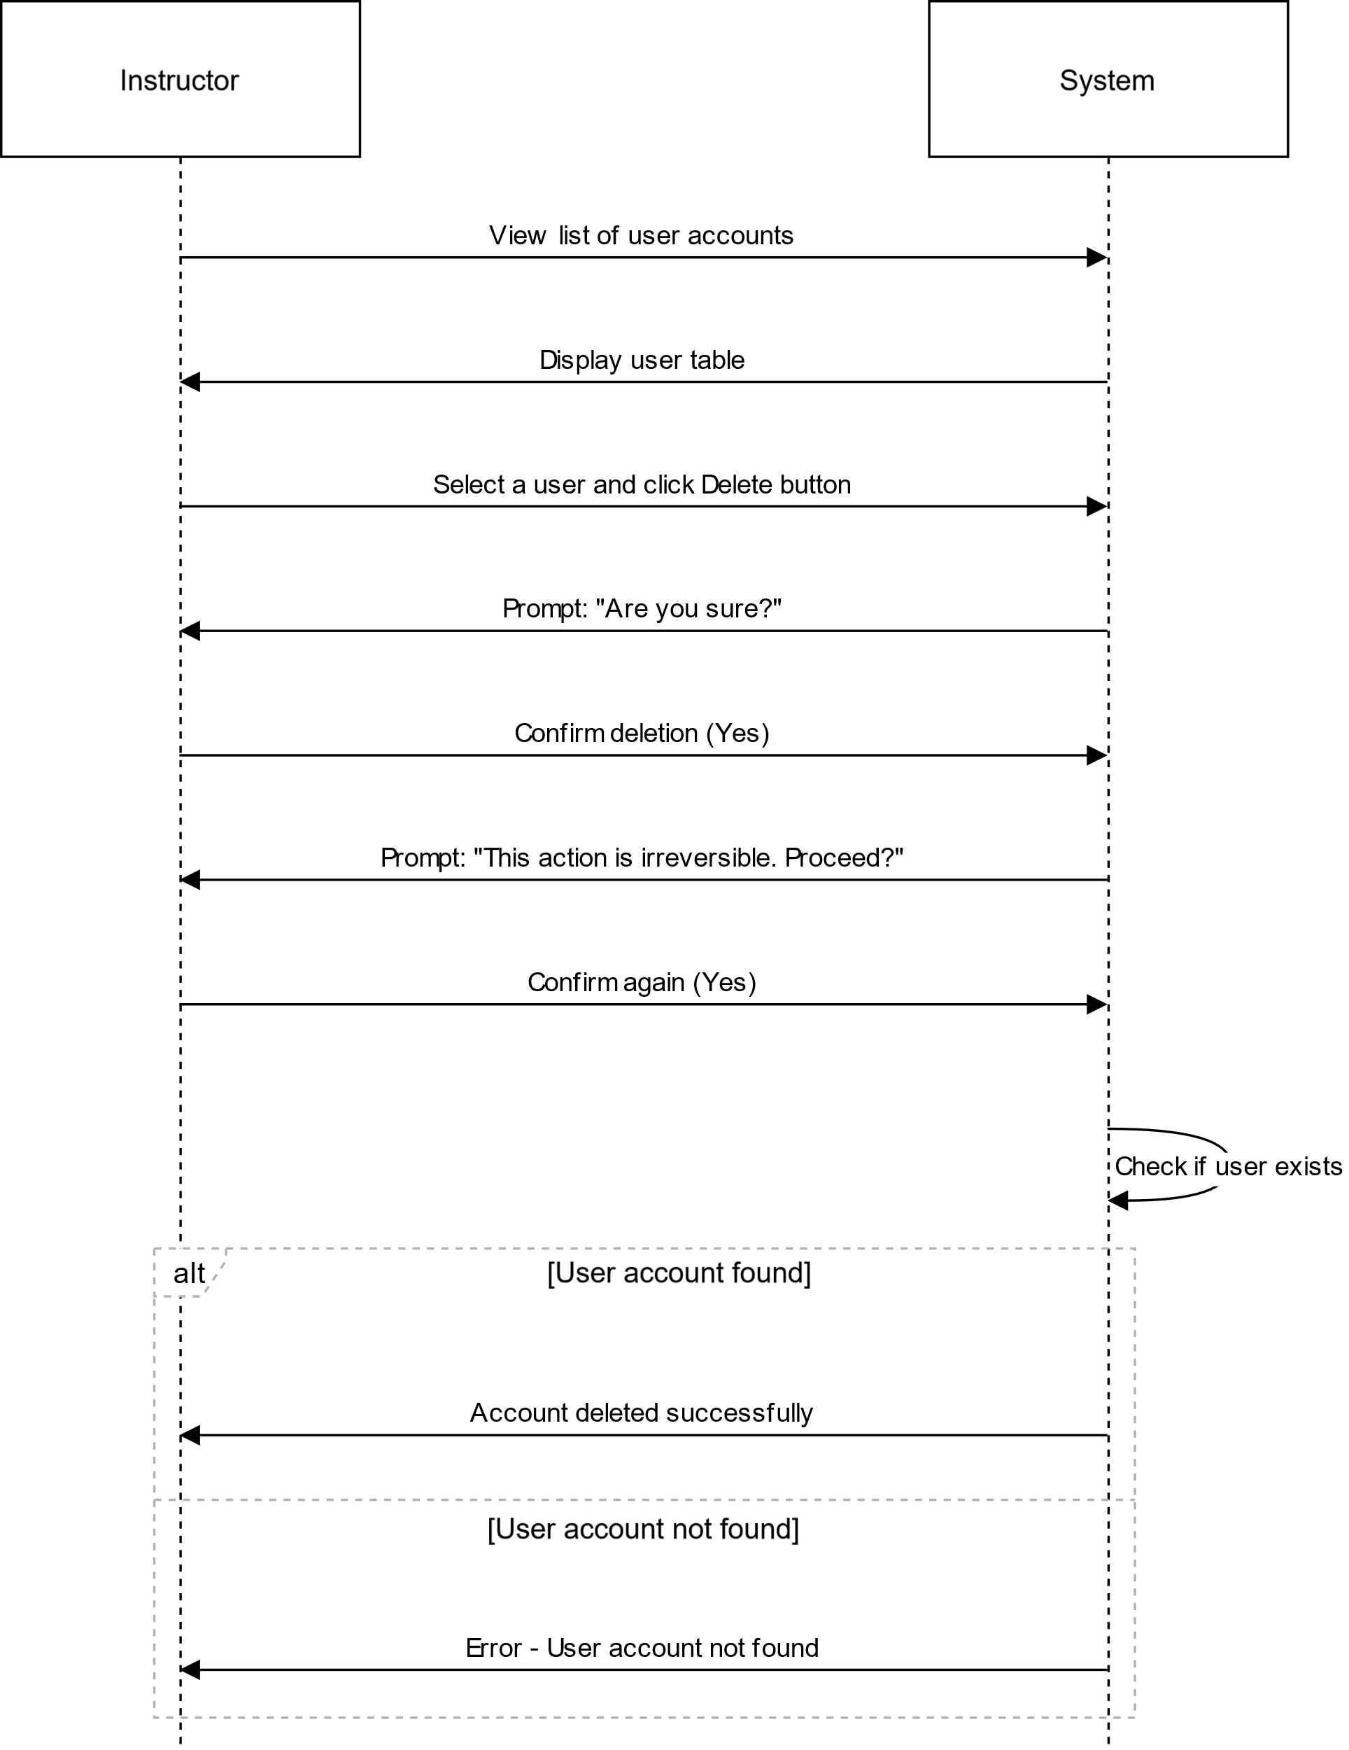

# US3

## USER LOGIN SSD

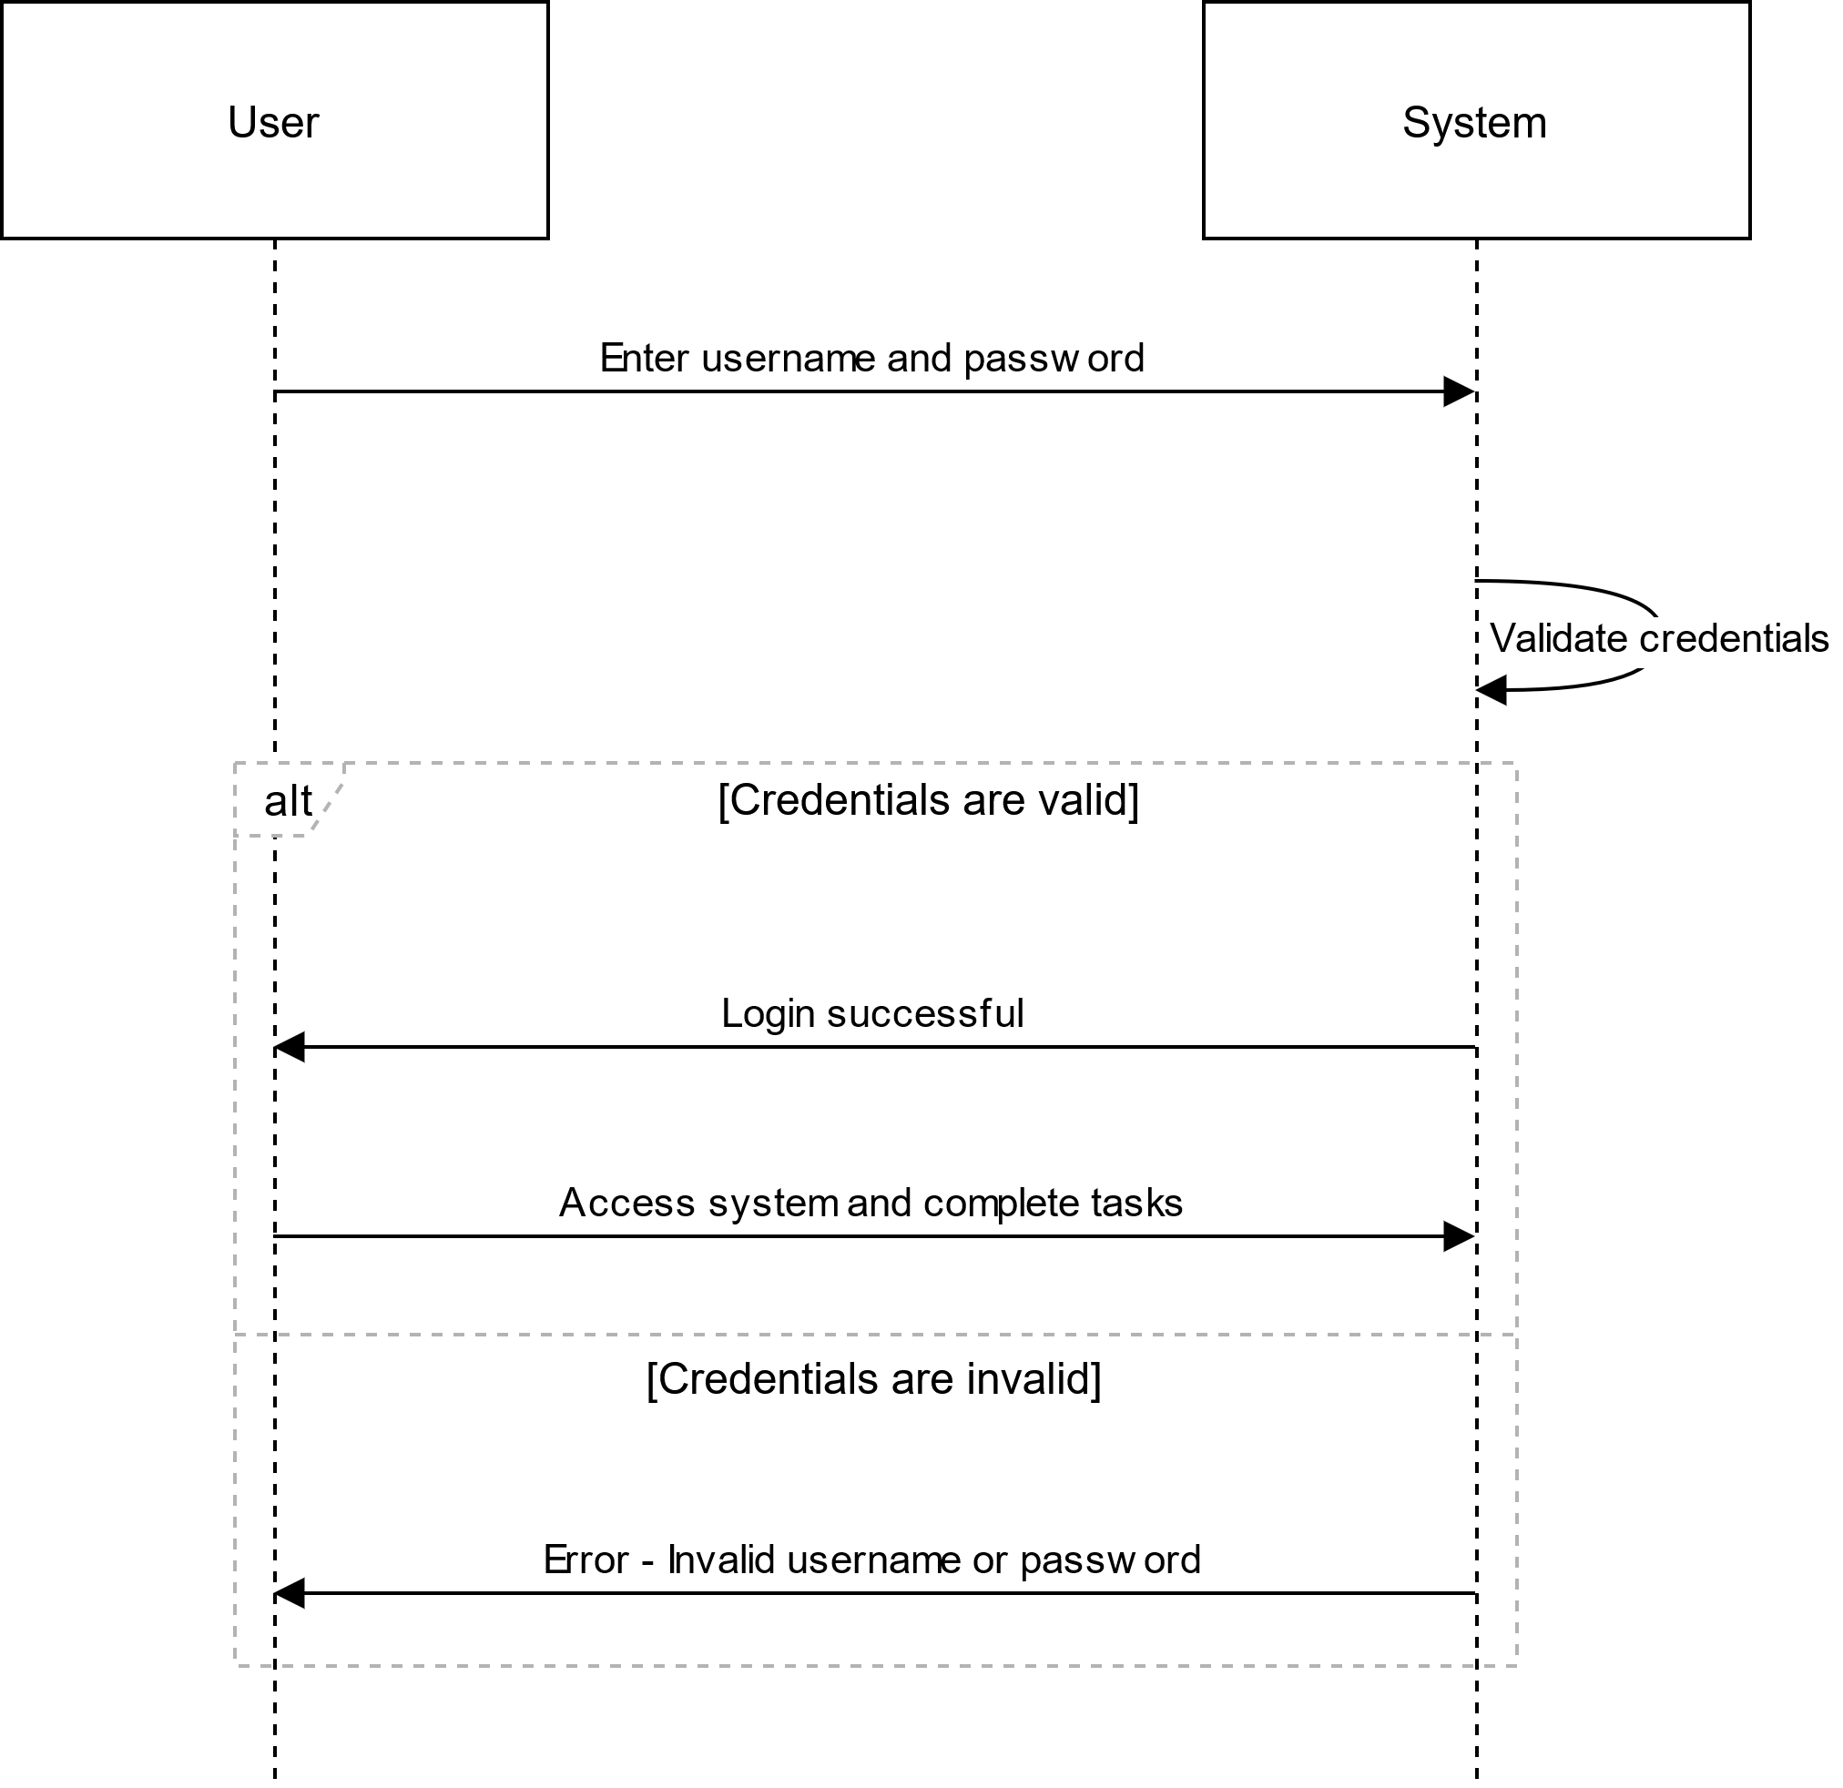

## RESET PASSWORD SSD

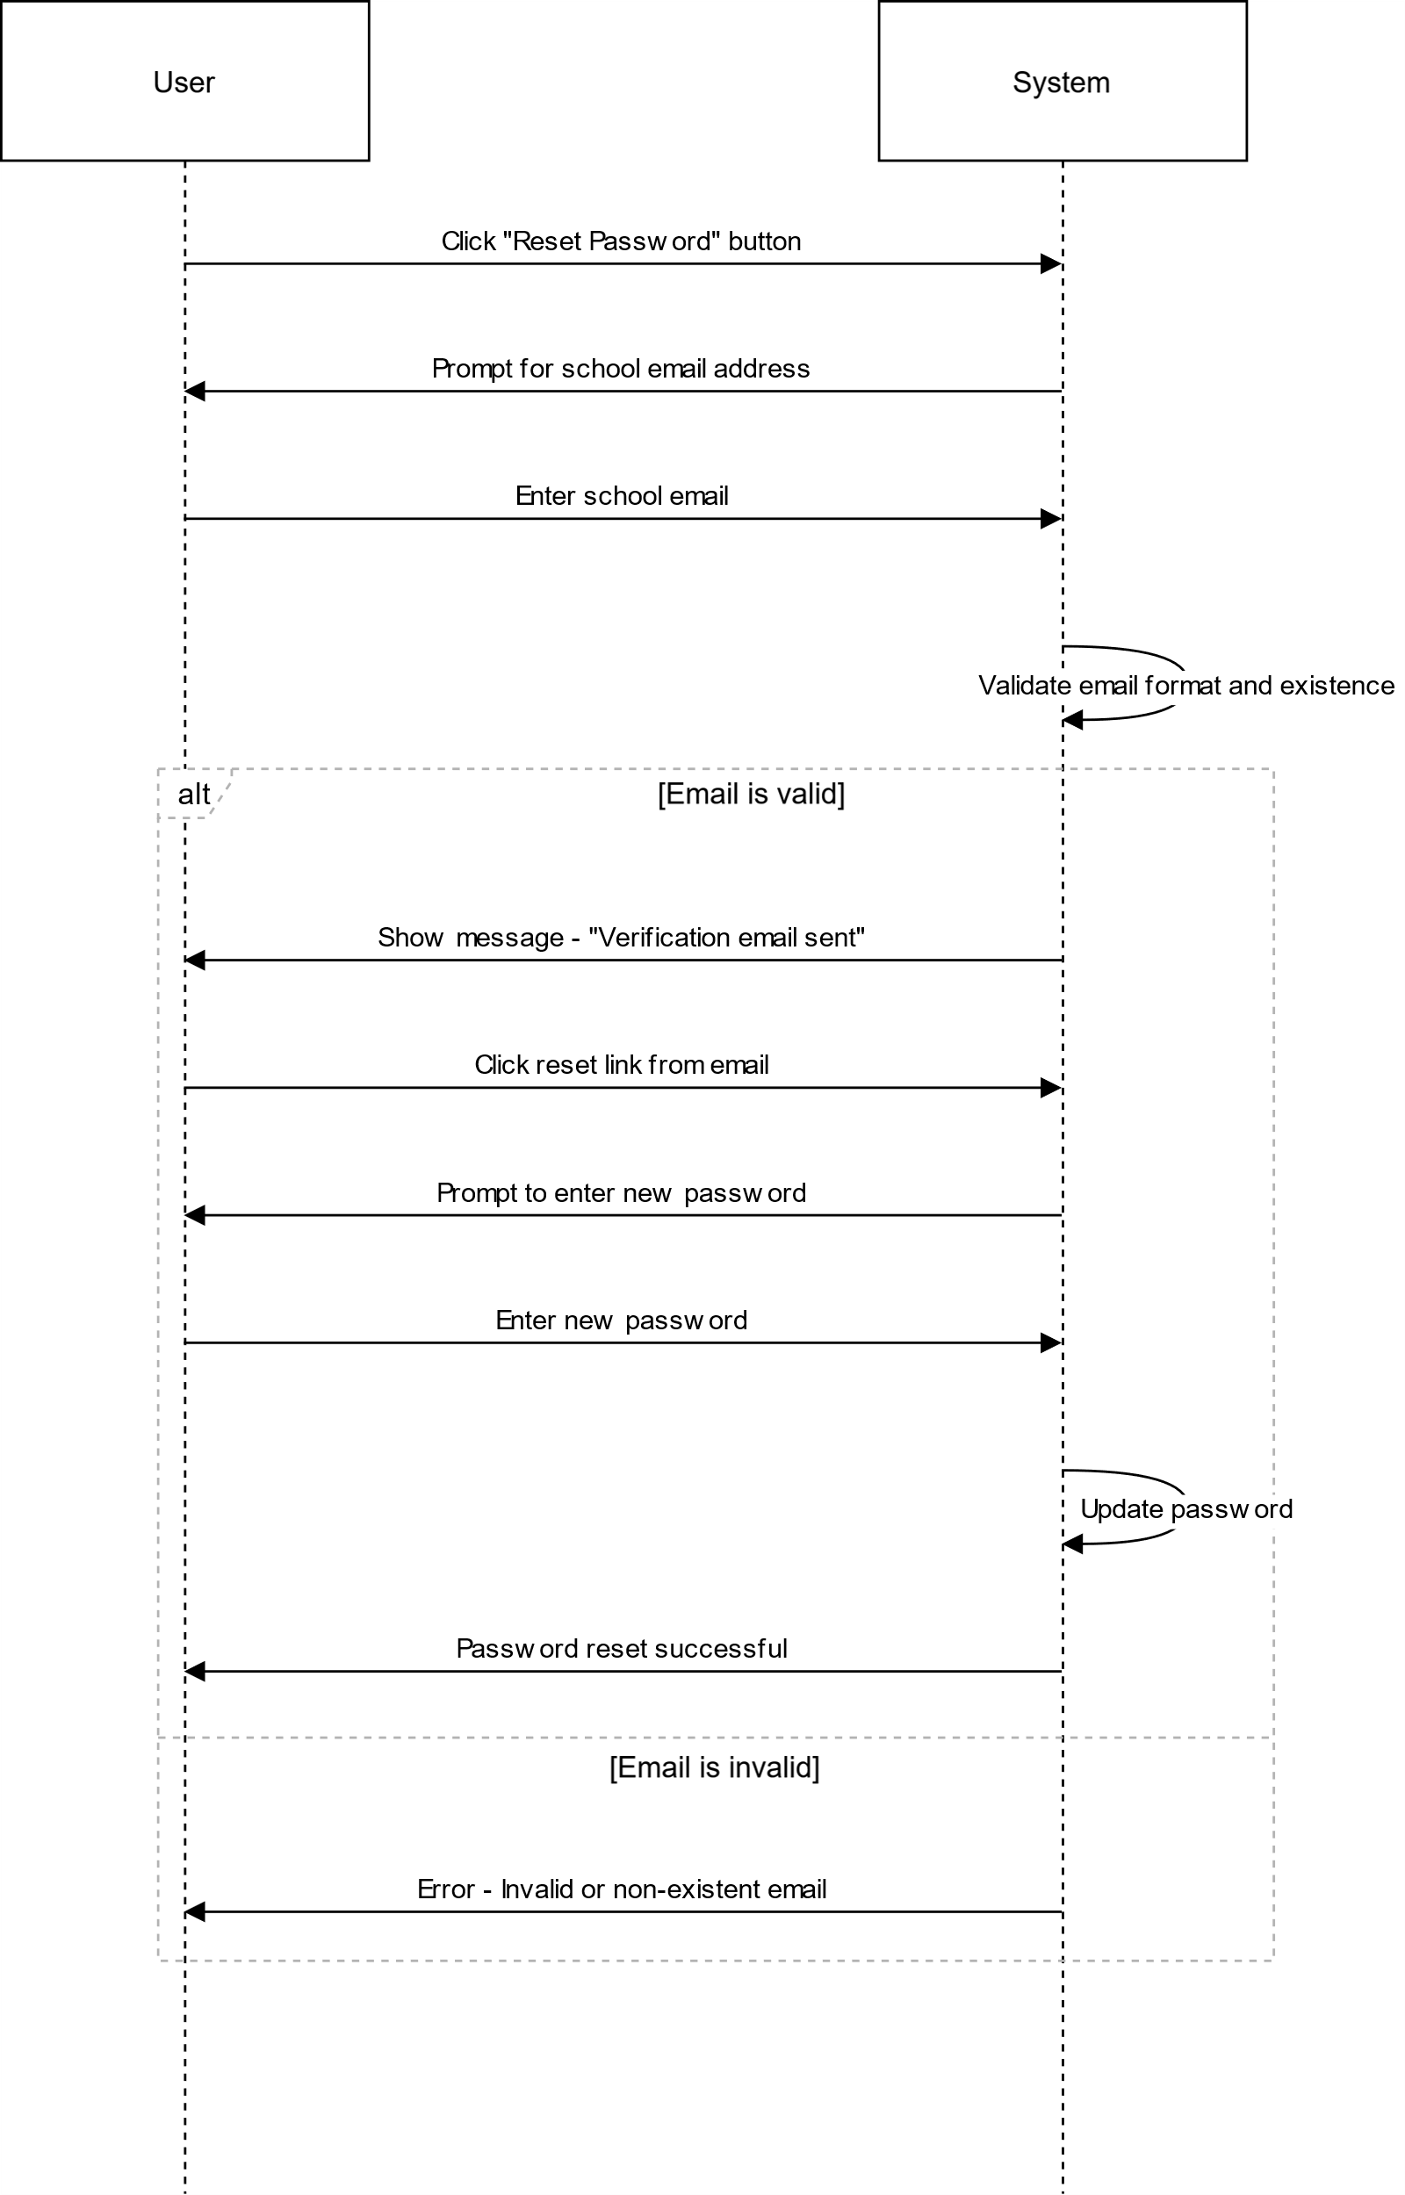

# US4

## CREATE ORDER SSD

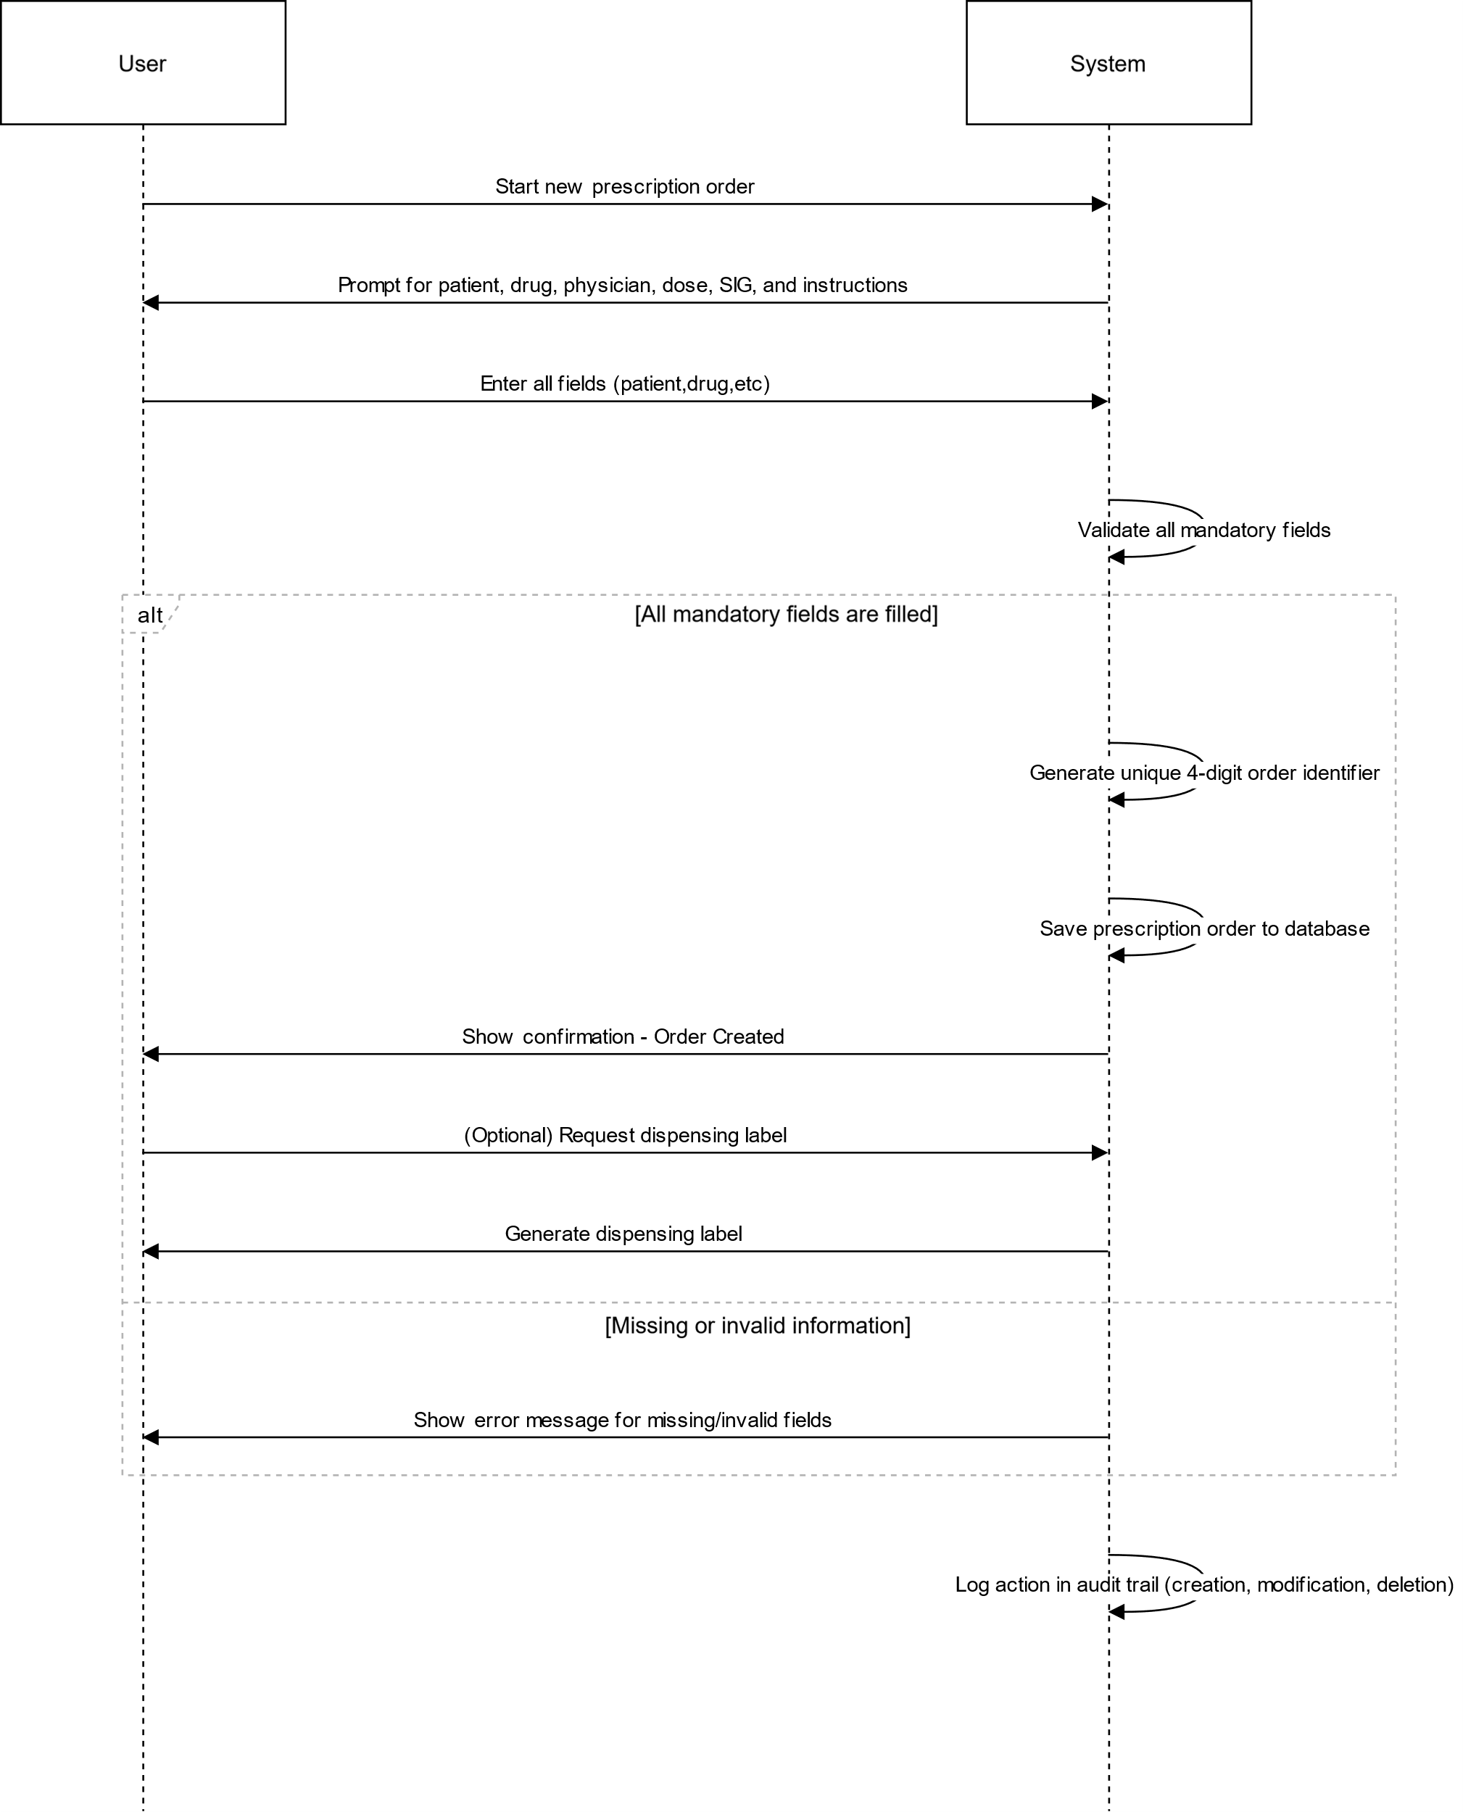

# US5

## IMAGE UPLOAD ON ADD ORDER PAGE

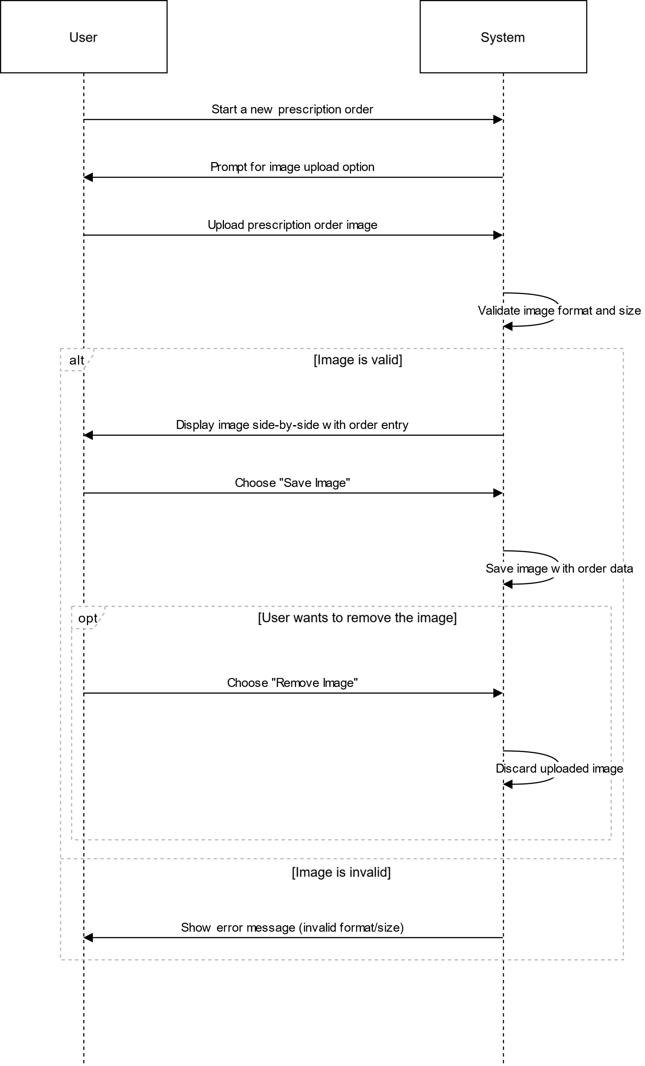

## IMAGE UPLOAD ON AMEND ORDER PAGE

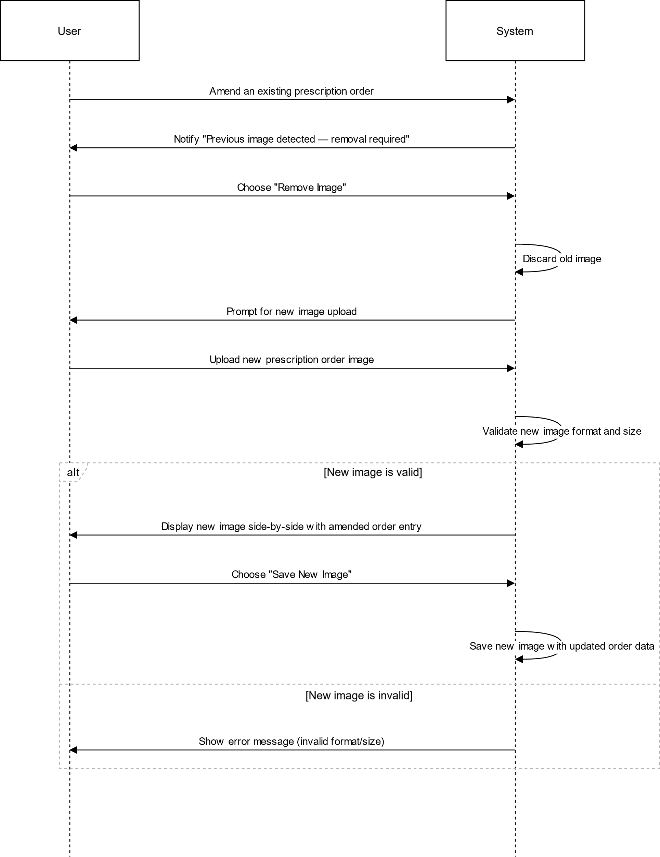

## IMAGE UPLOAD ON VERIFICATION PAGE

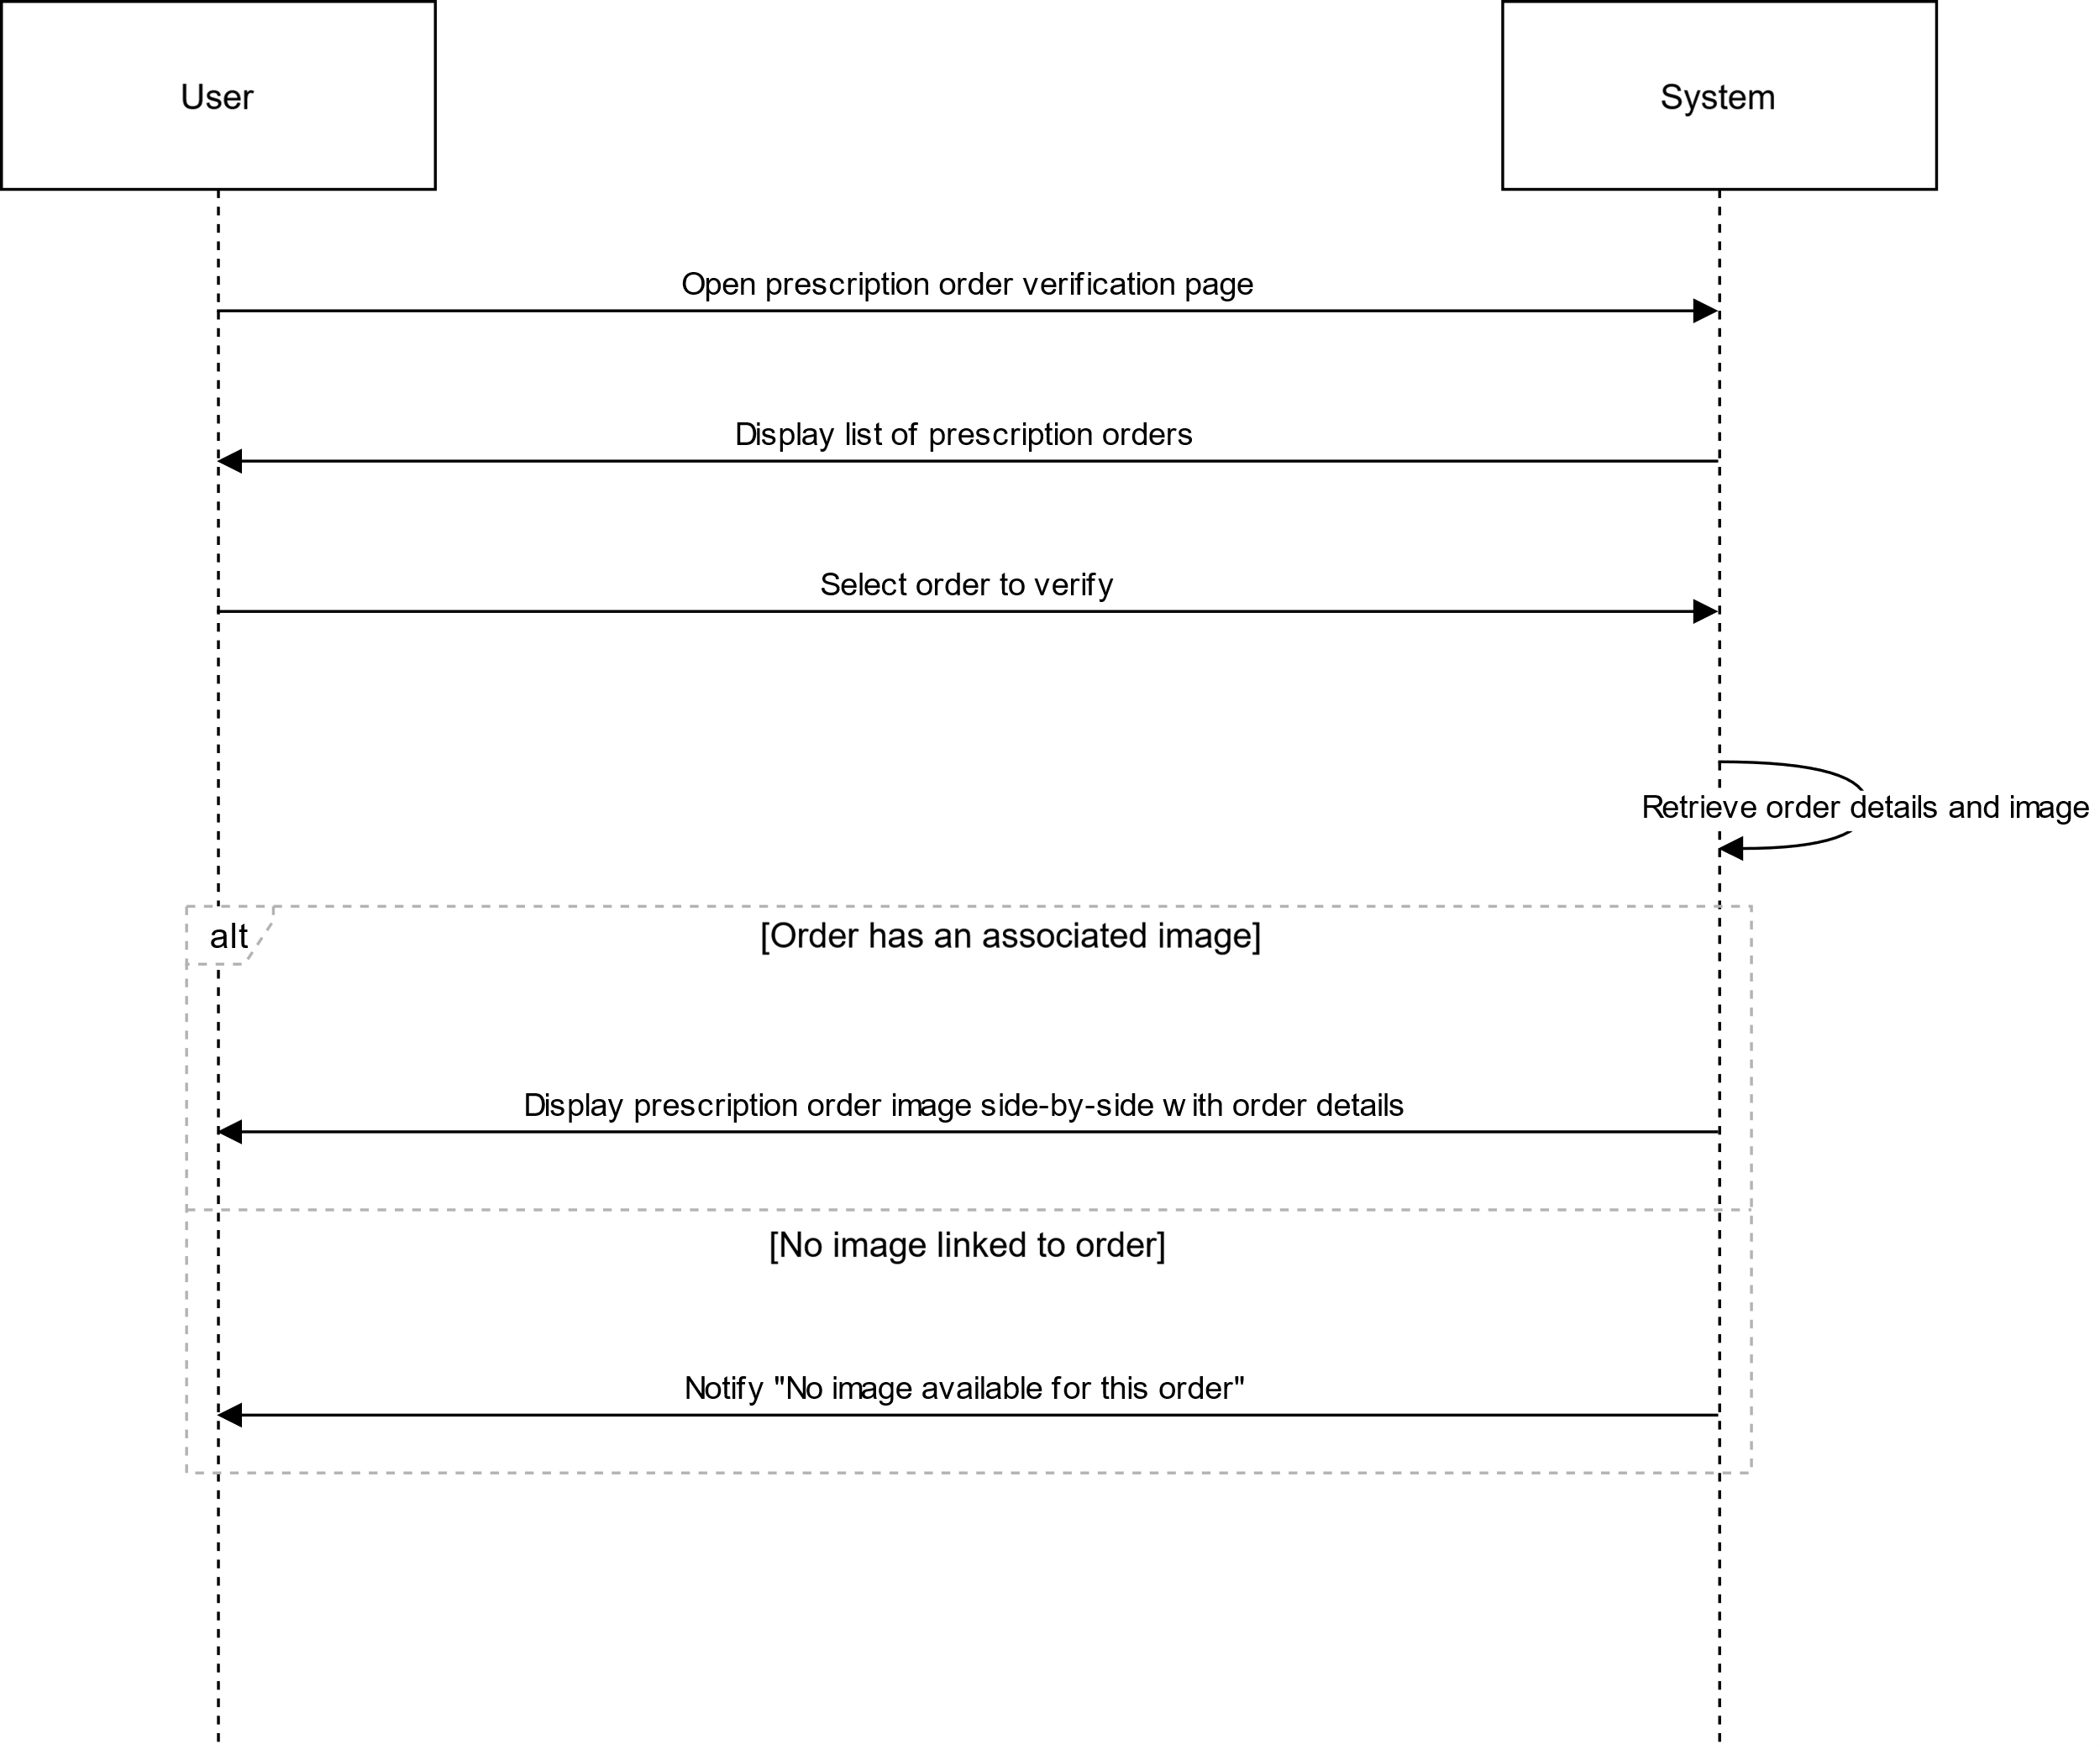

# US7

## VERIFY ORDER SSD

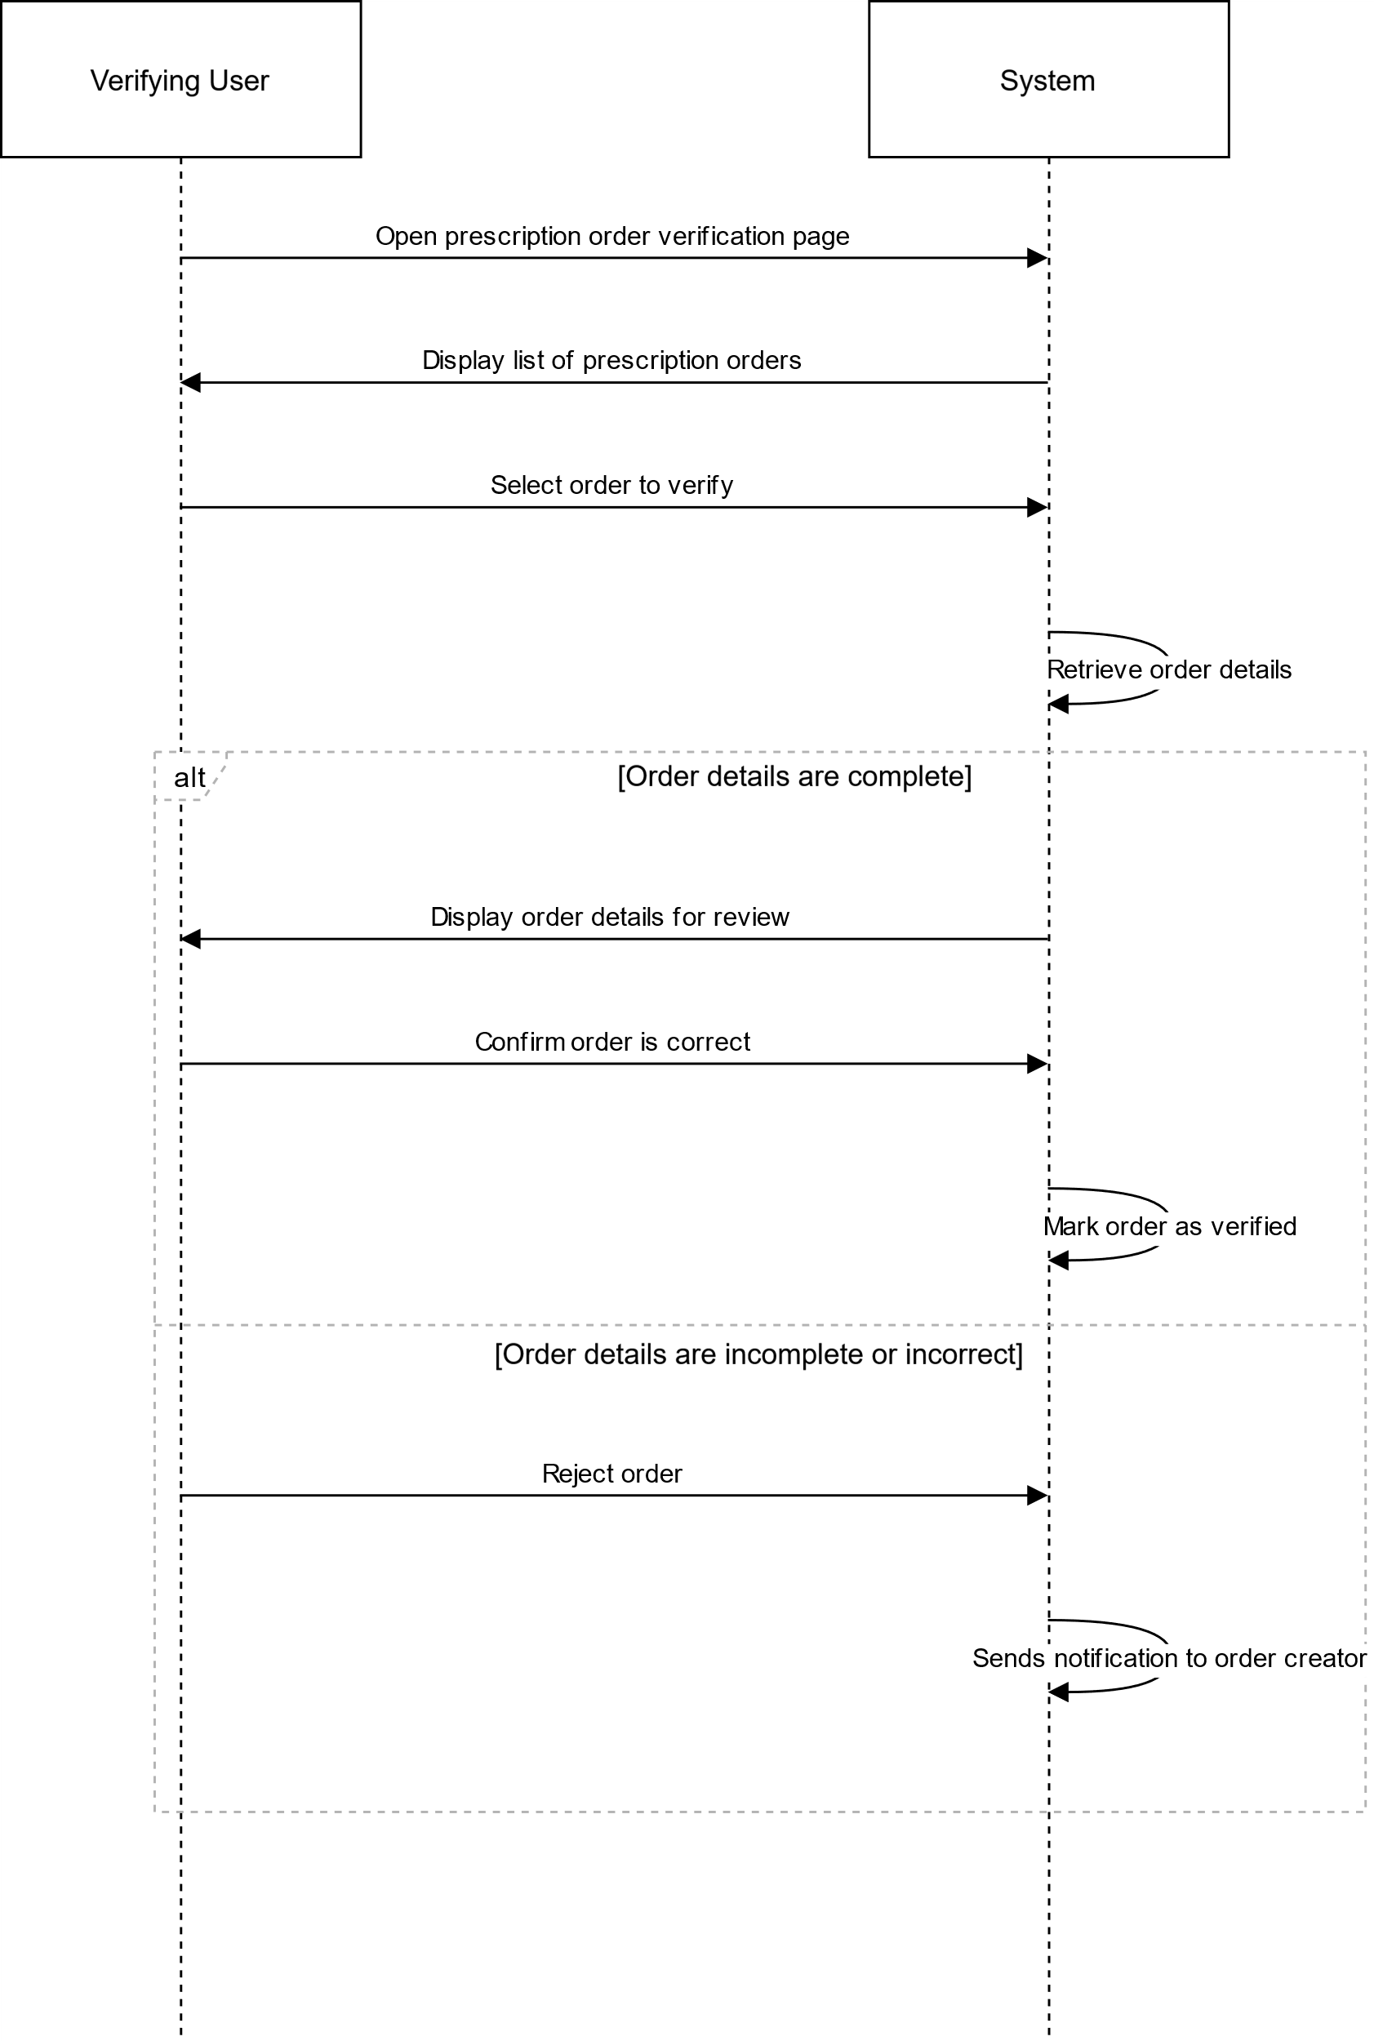

# US8

## AMEND ORDER

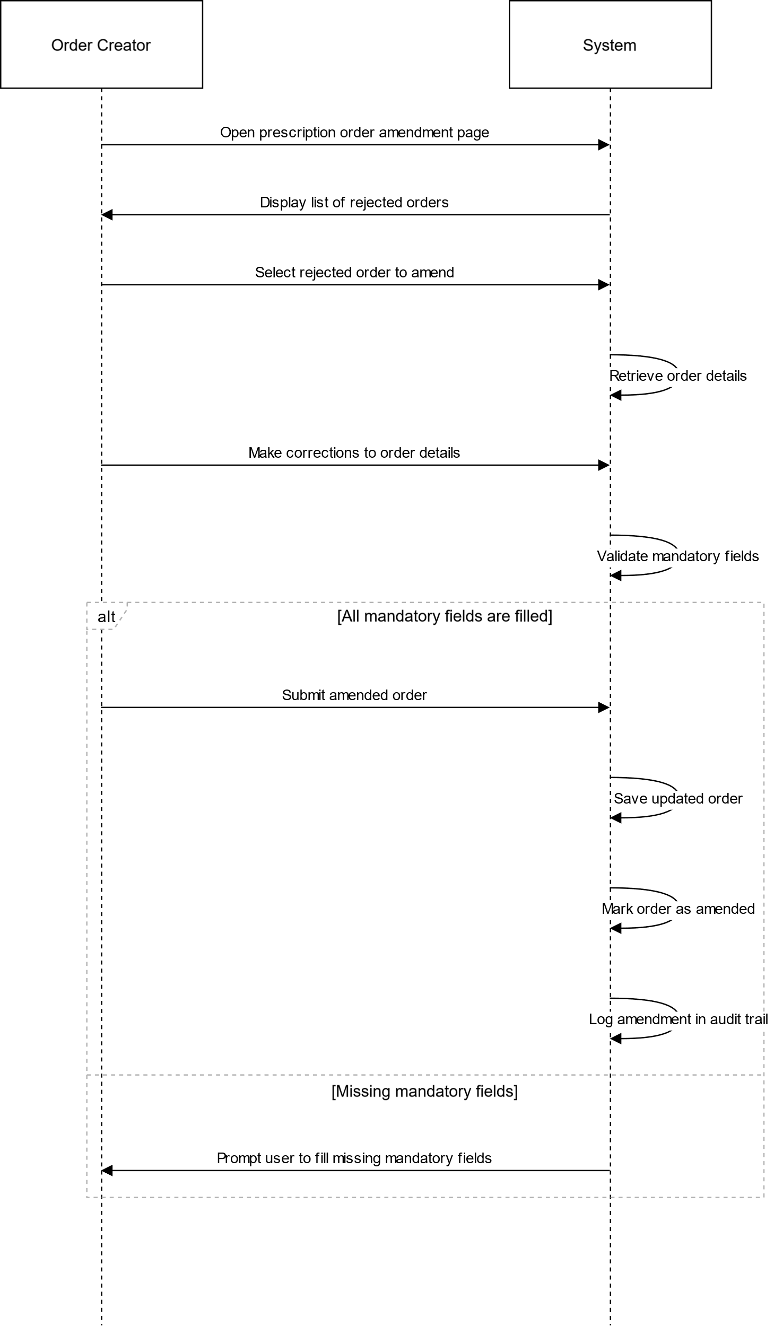

# US9

## PRINT DISPENSING LABEL SSD

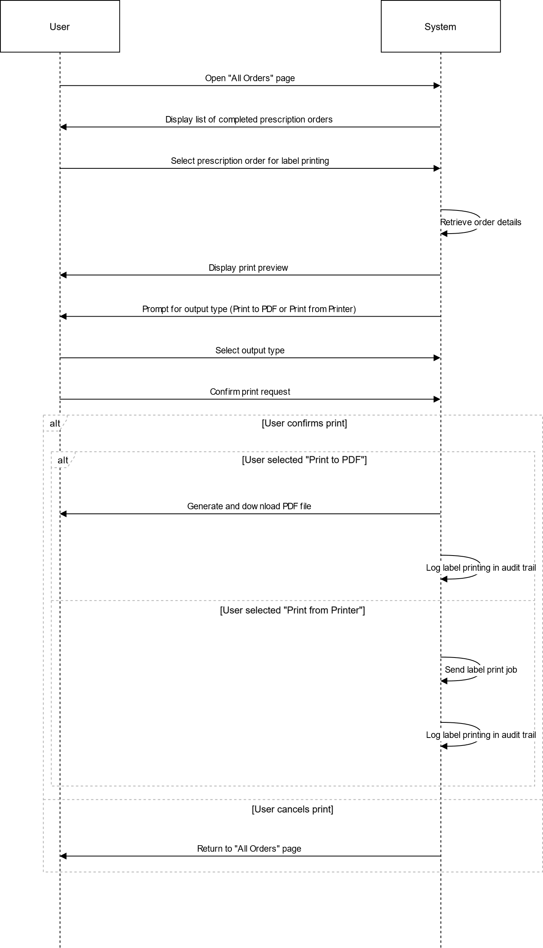

# US10

## RE-PRINT DISPENSING LABEL SSD

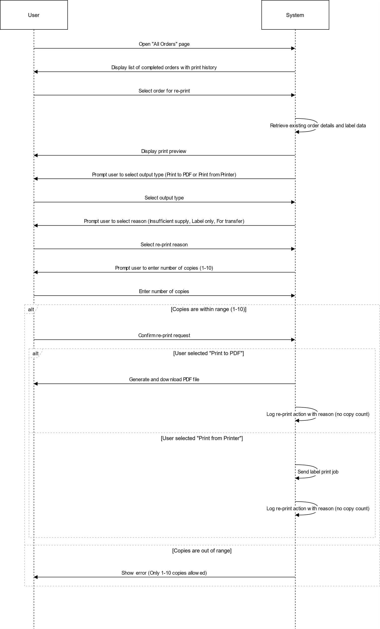

# US11

## INACTIVITY SSD

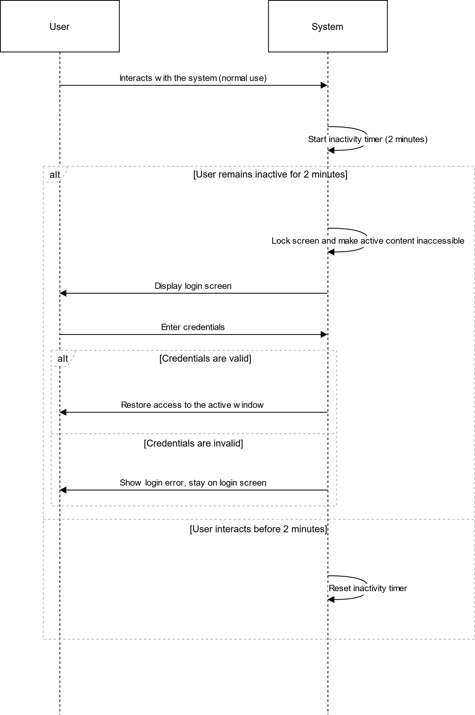

# US12

## VIEW ORDERS

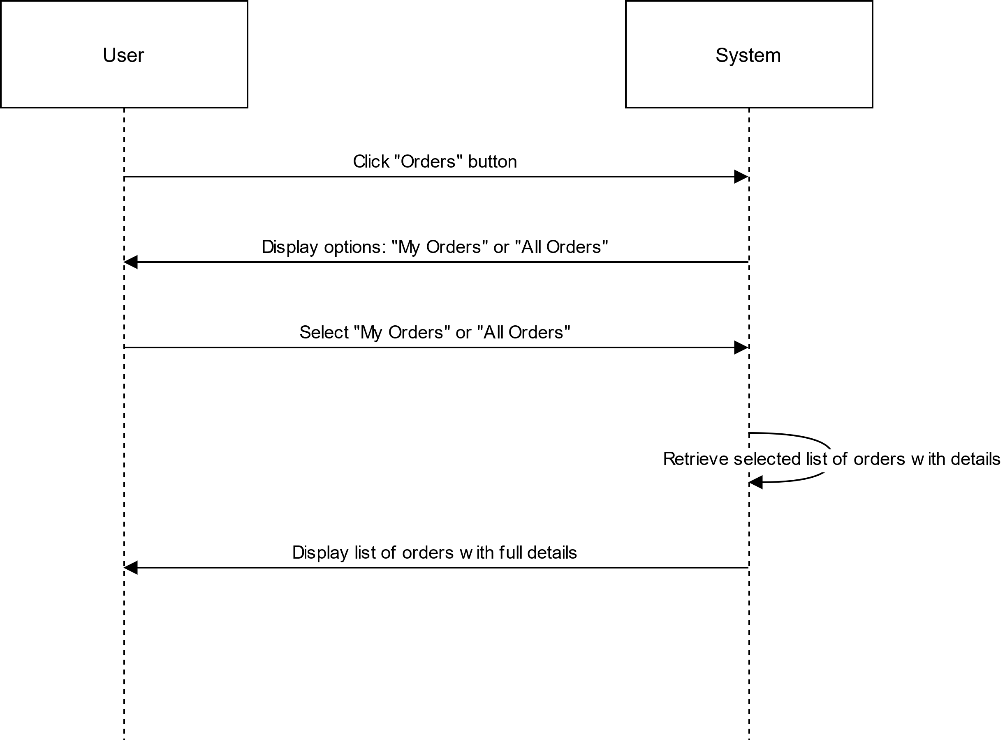

## ORDERS TO VERIFY

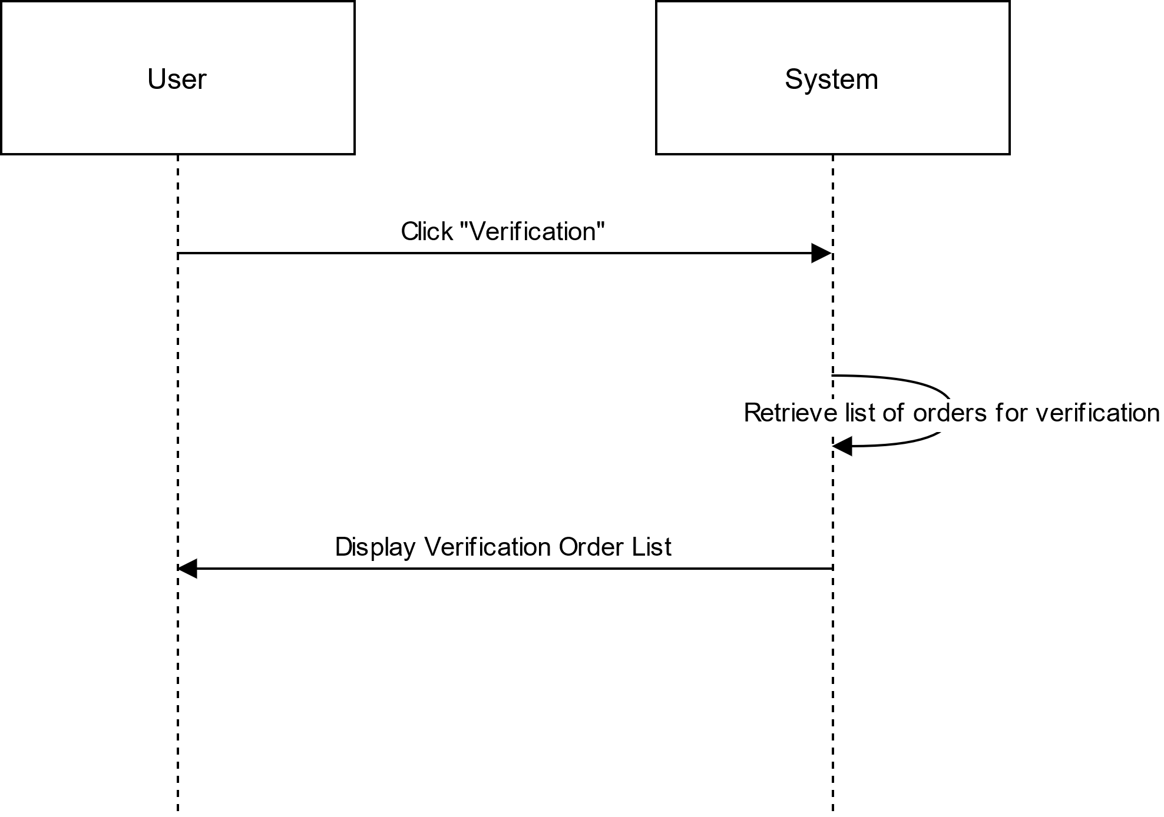

# US13

## ADD DRUG

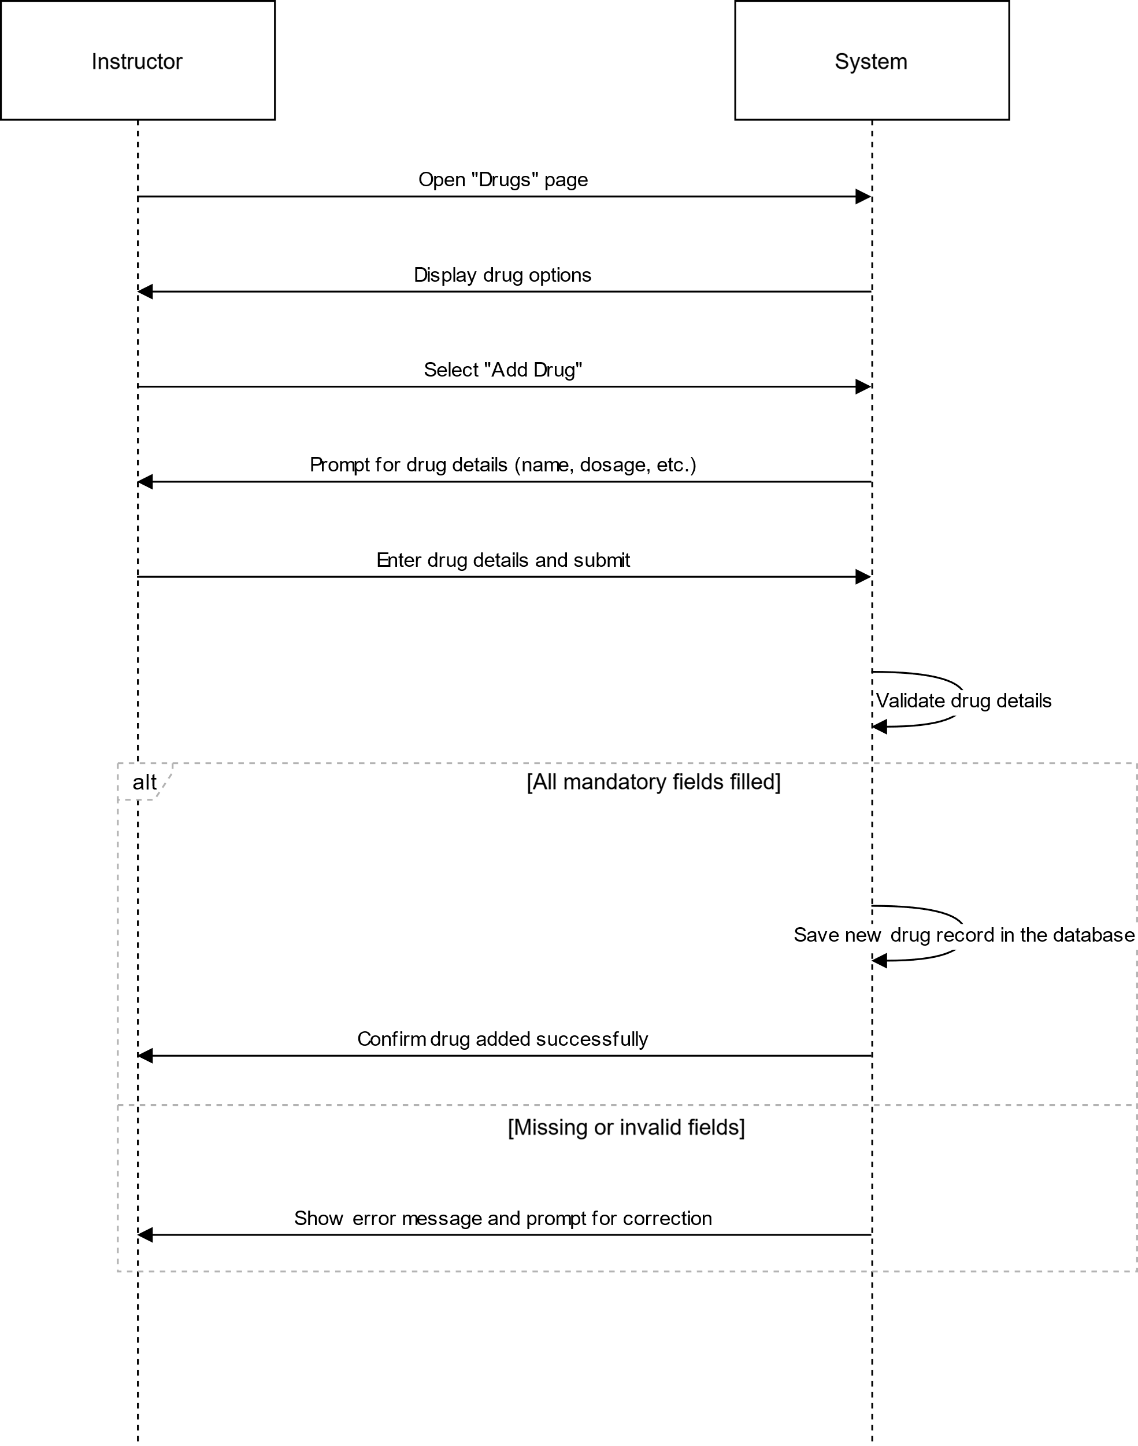

# US14

## VIEW DRUGS

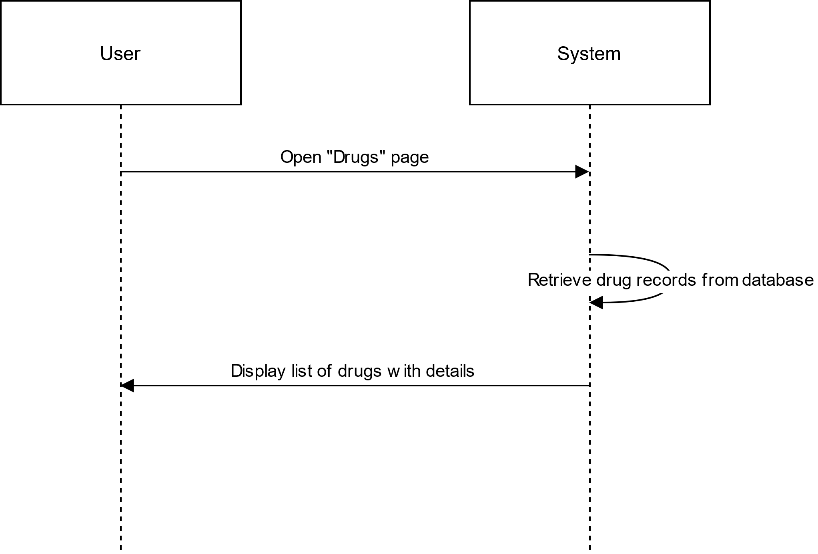

# US15

## DELETE DRUG(S)

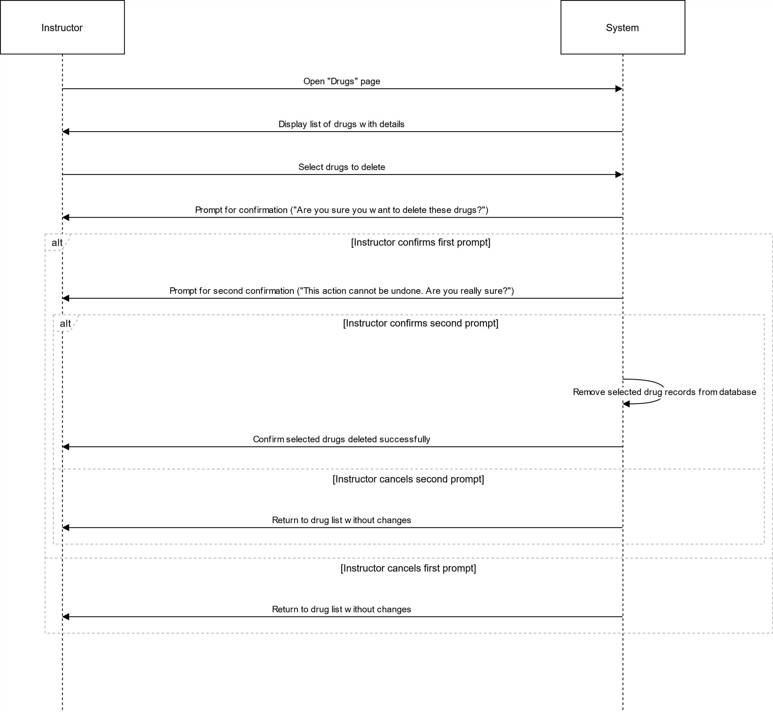

# US16

## EDIT DRUG

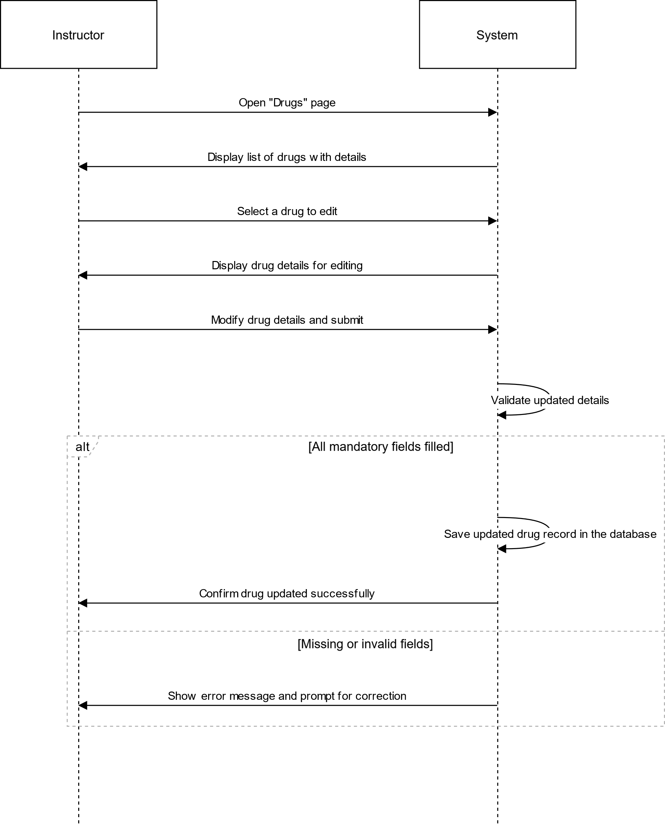

# US17

## ADD PHYSICIAN

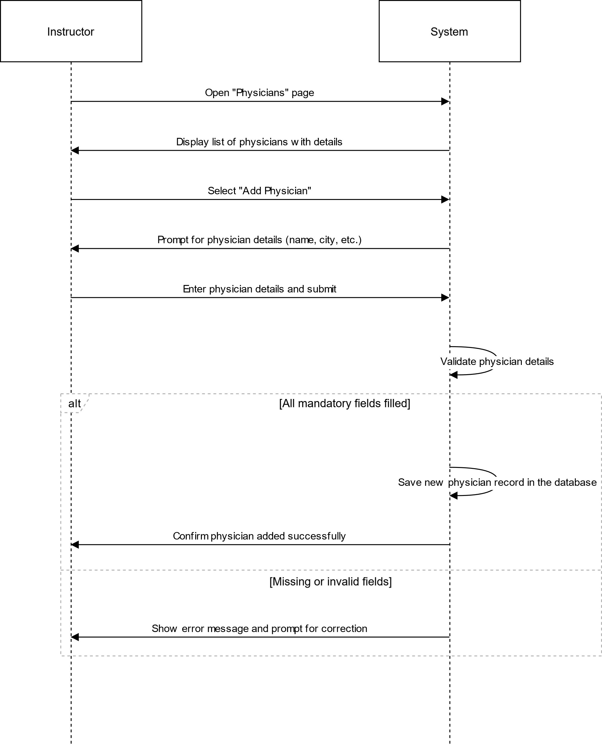

# US18

## VIEW PHYSICIANS

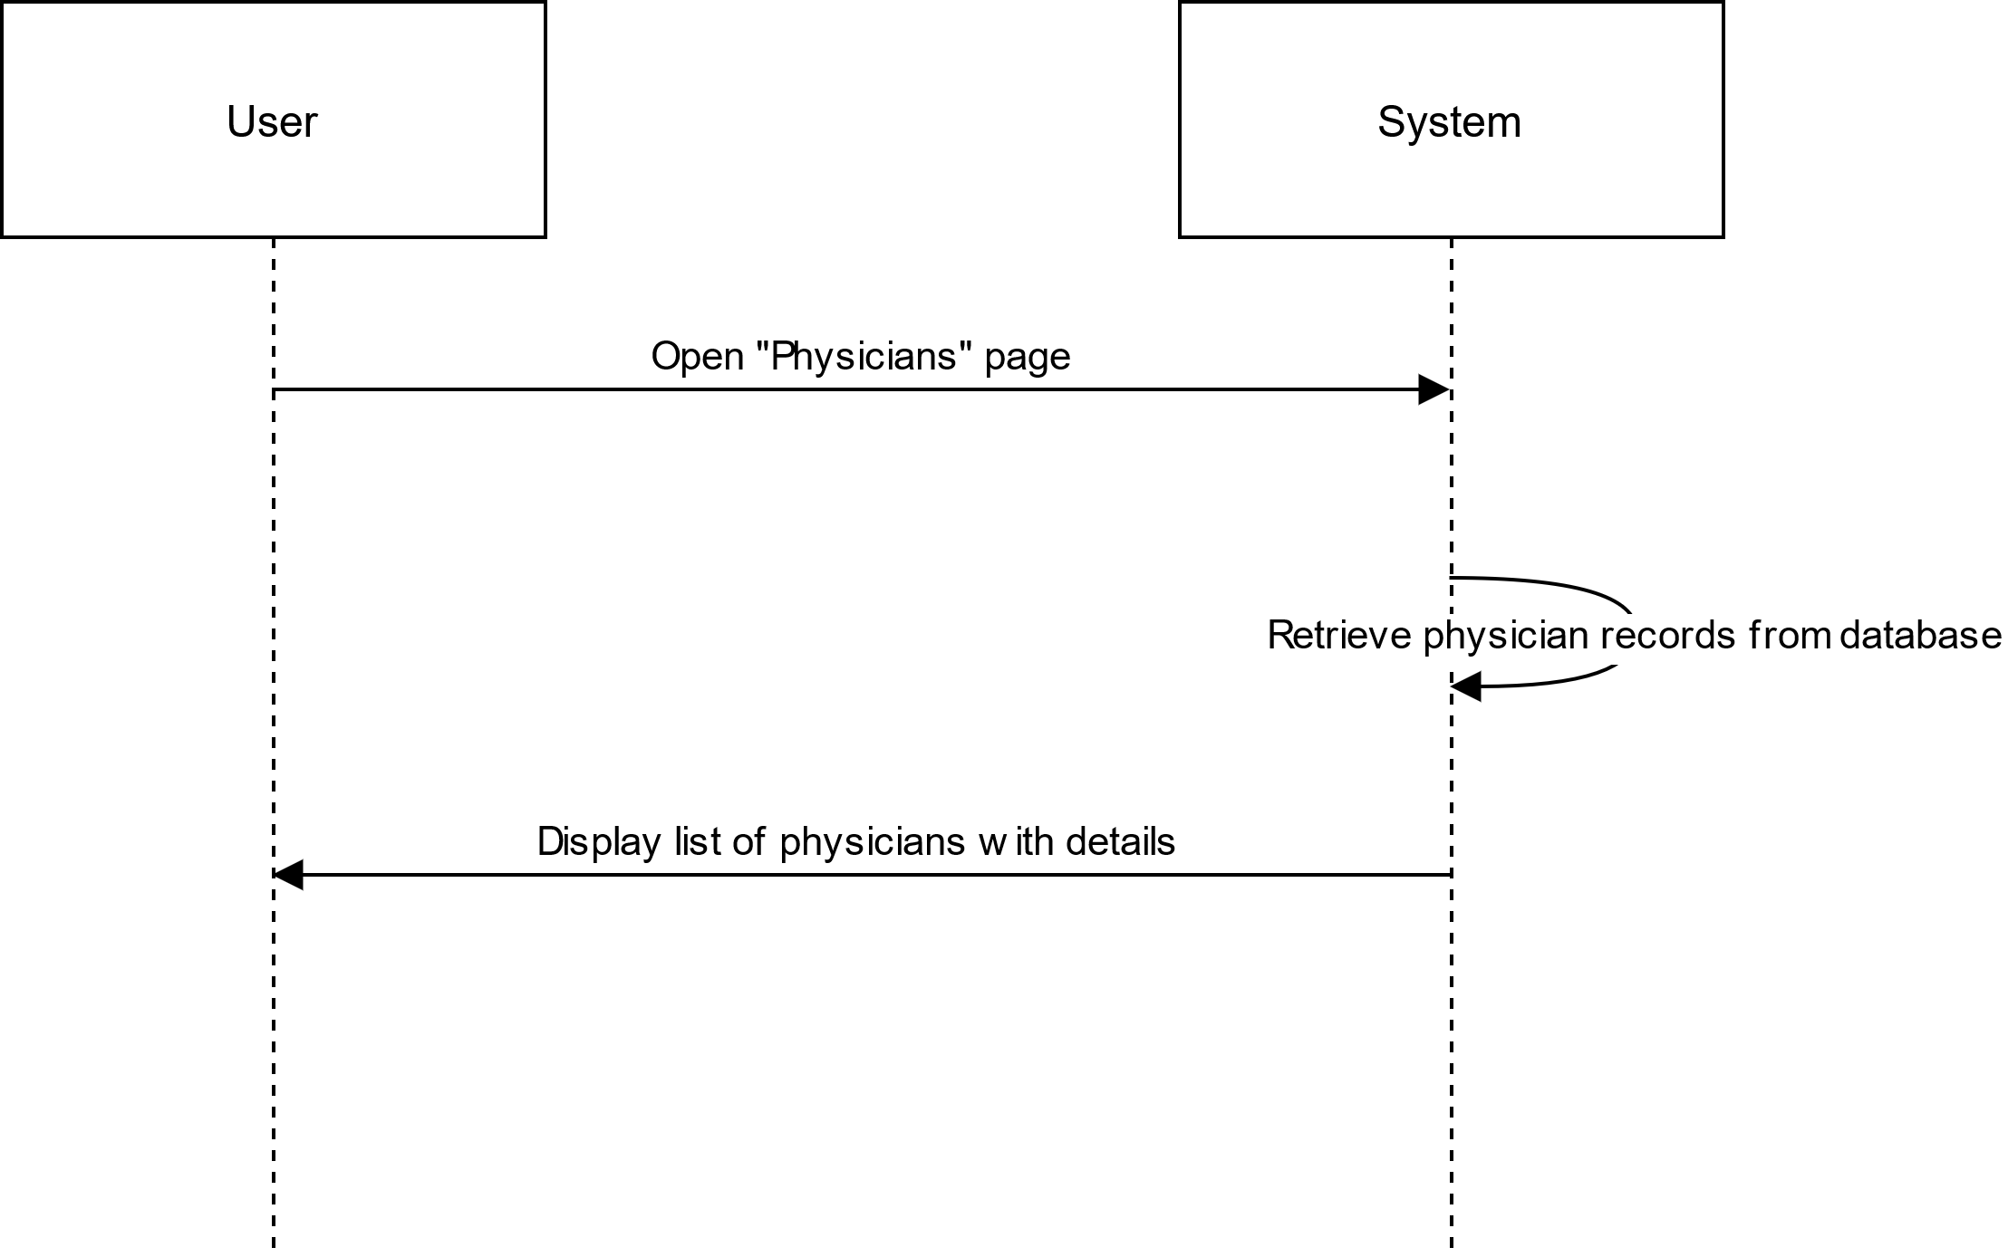

# US19

## DELETE PHYSICIAN(S)

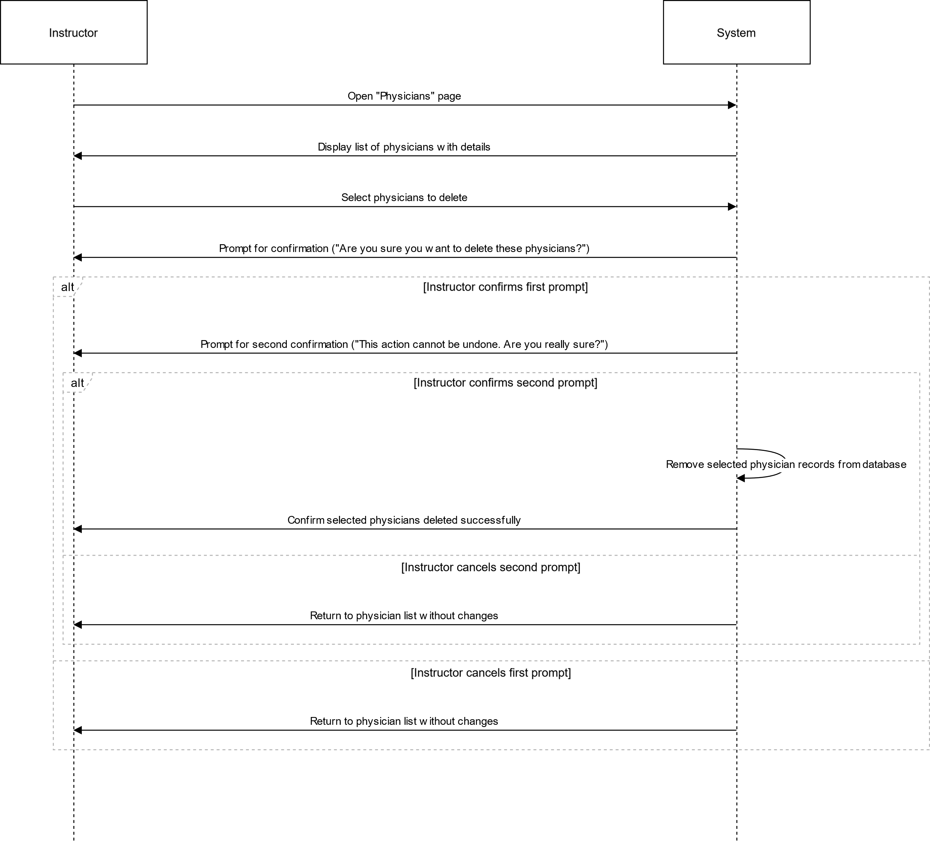

# US20

## EDIT PHYSICIAN

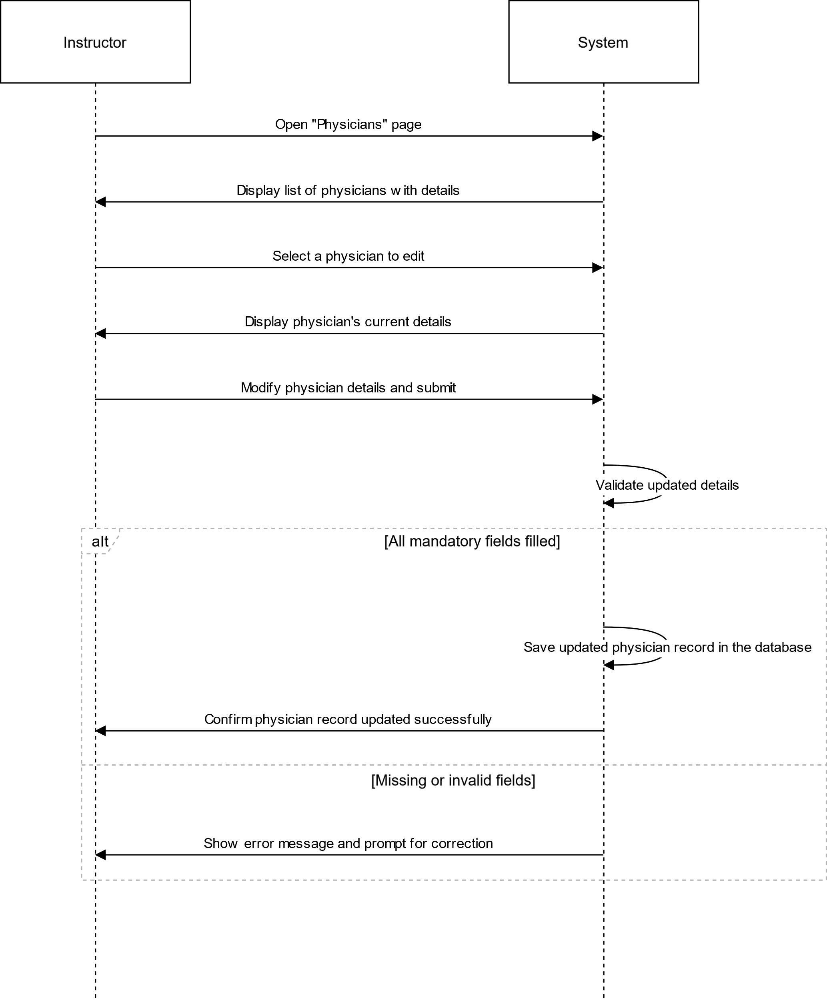

# US21

## ADD PATIENT

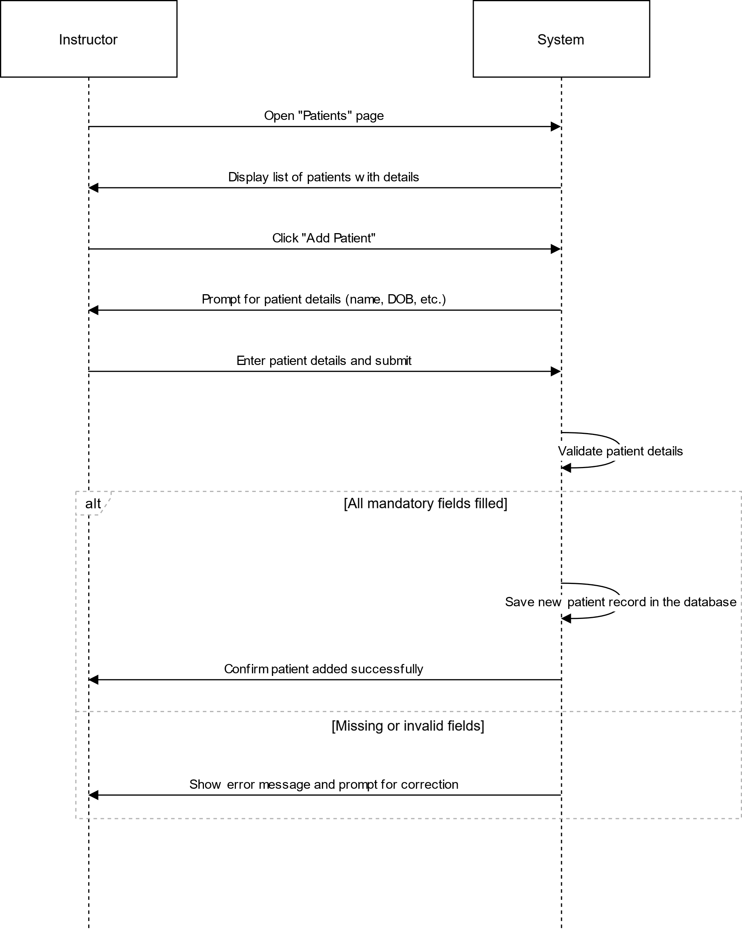

# US22

## VIEW PATIENTS

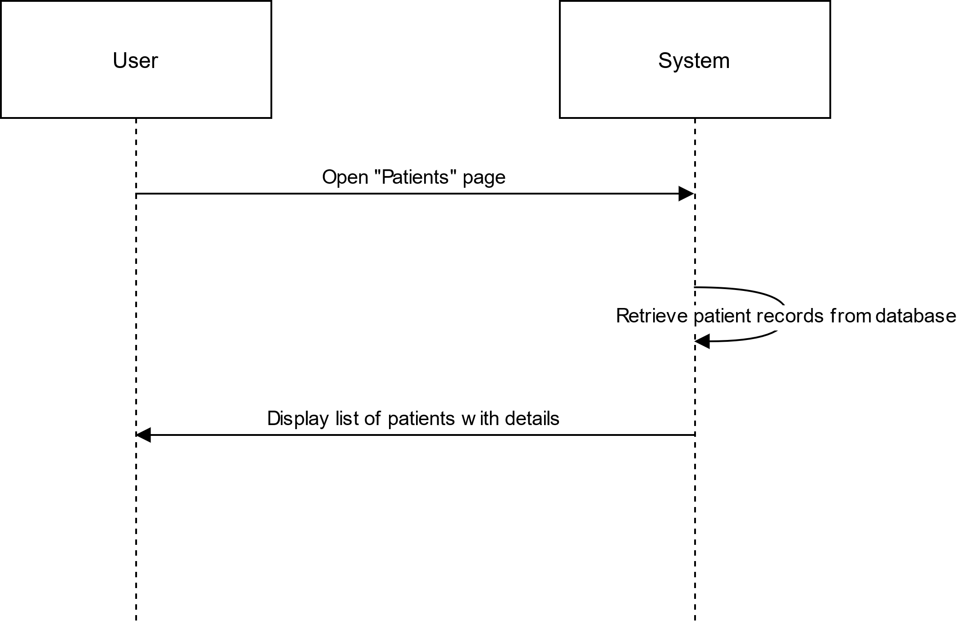

# US23

## DELETE PATIENT(S)

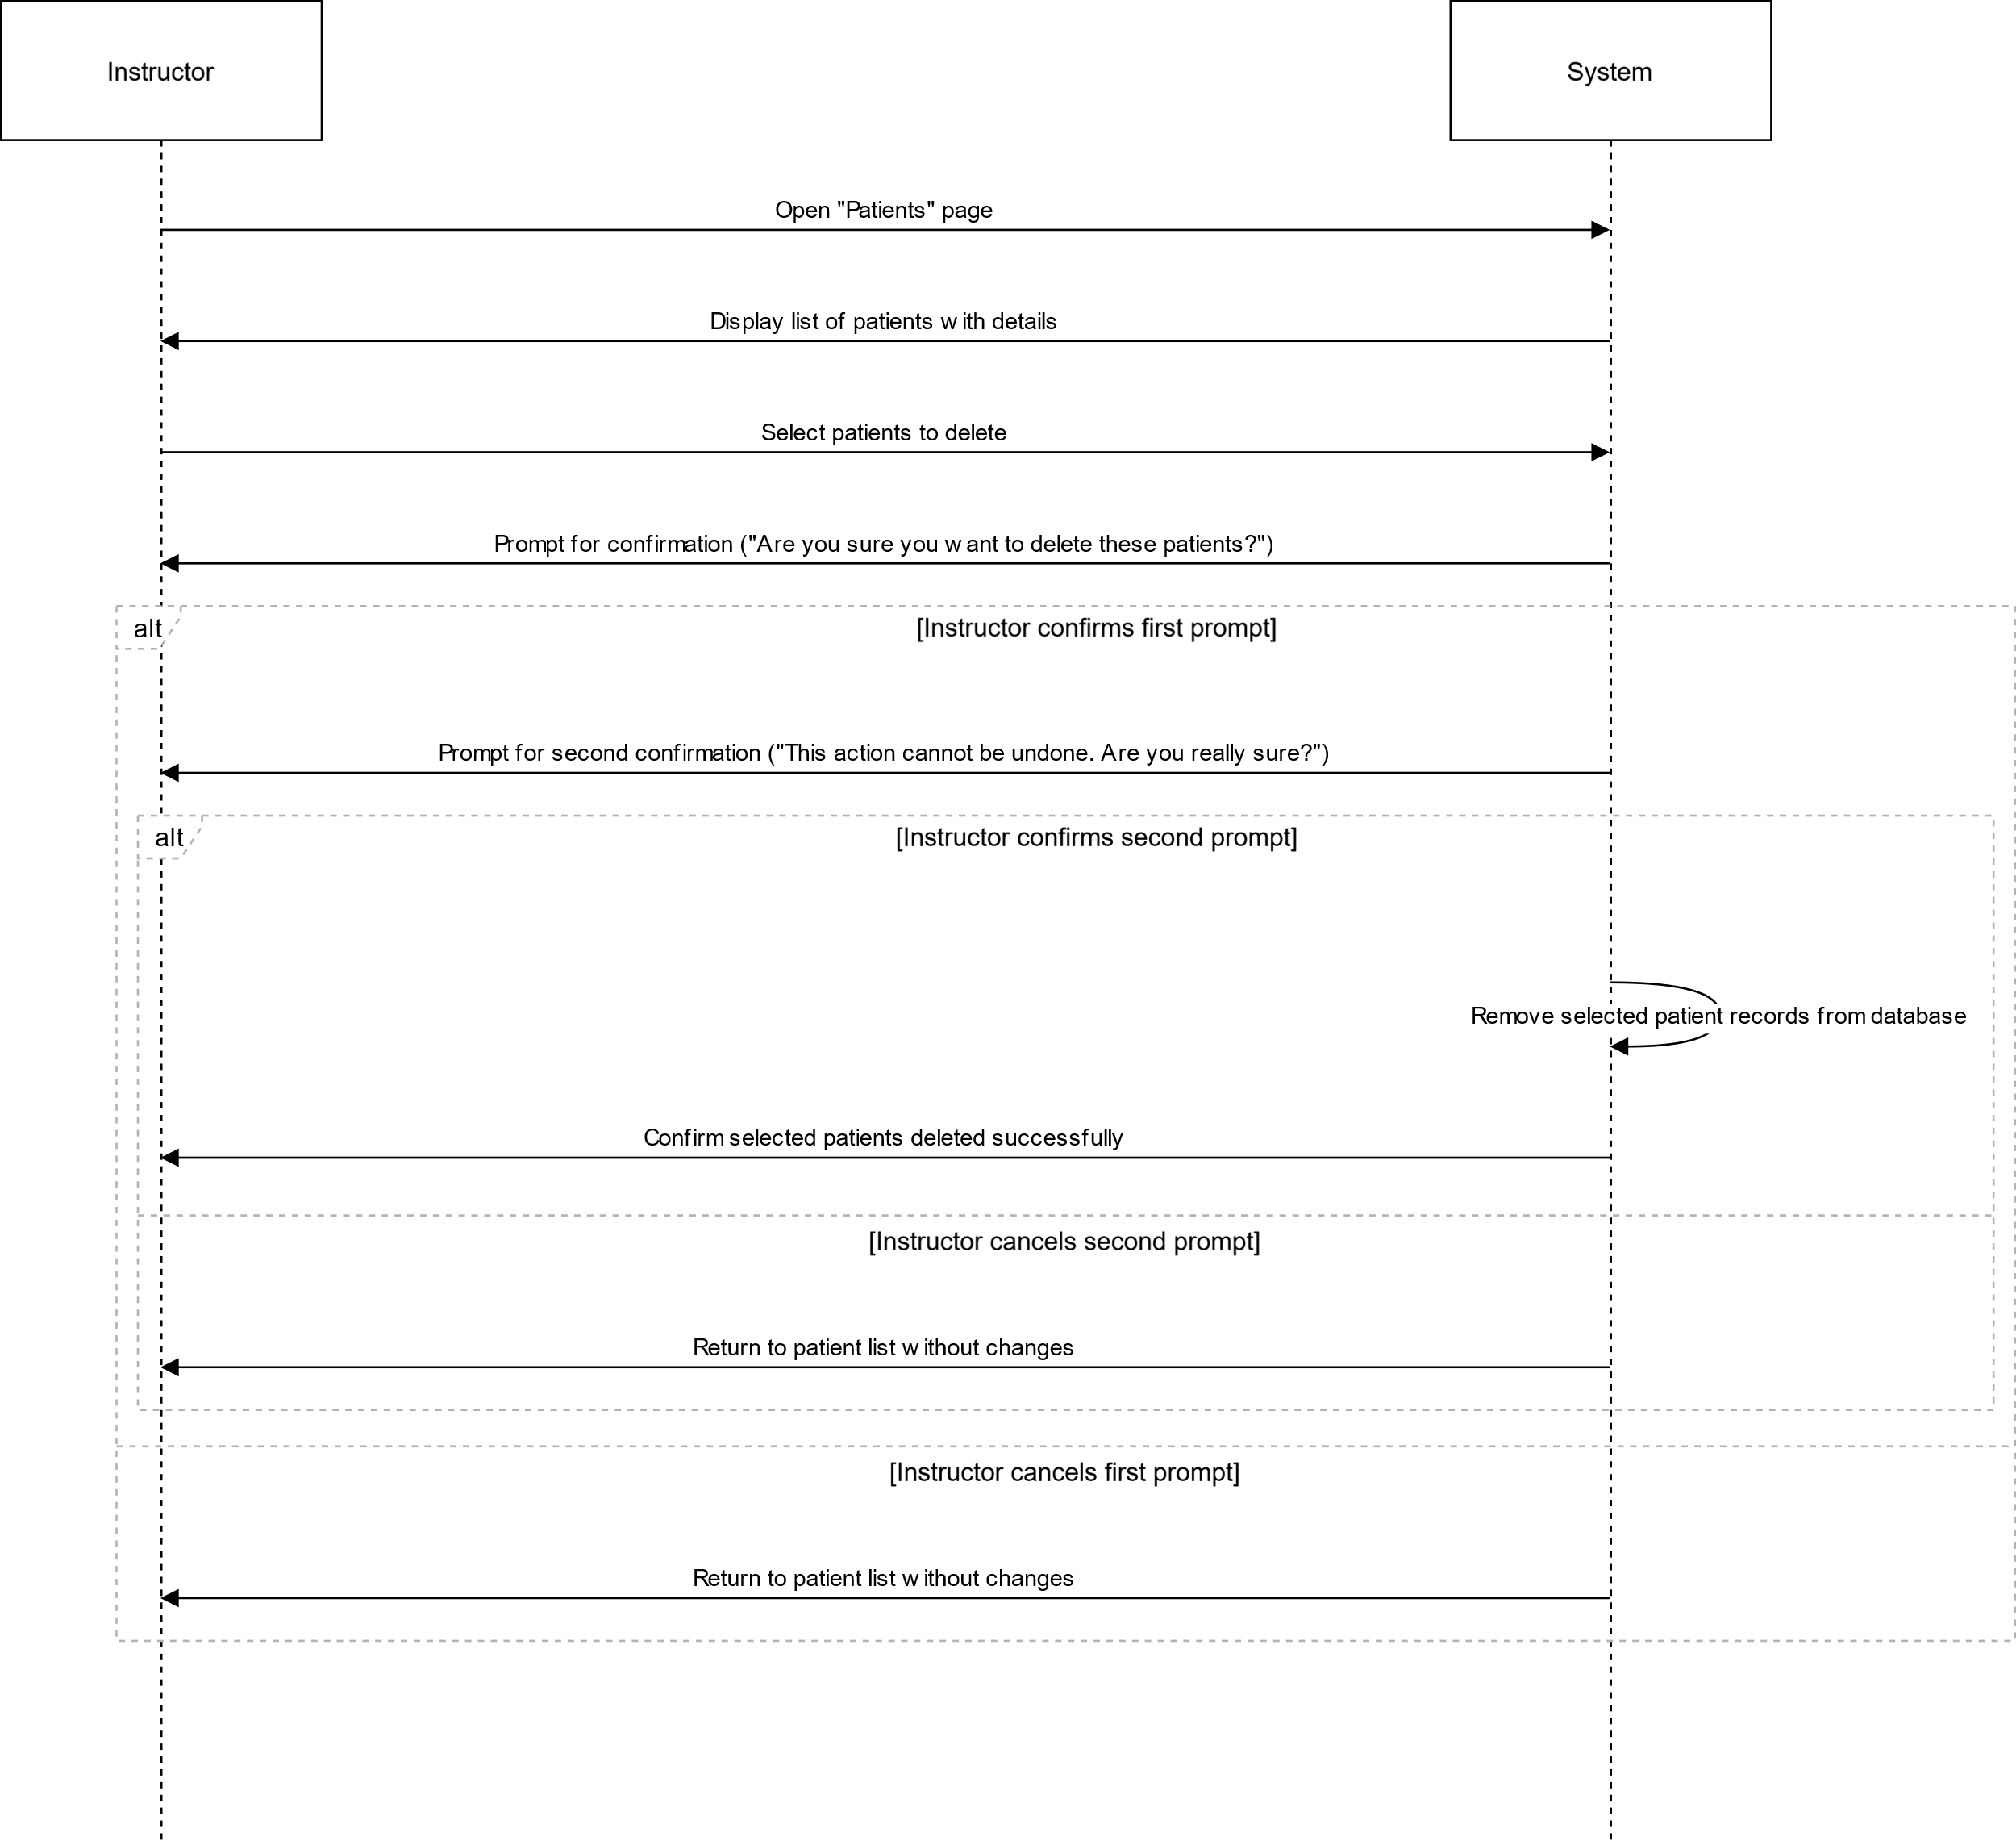

# US24

## EDIT PATIENT

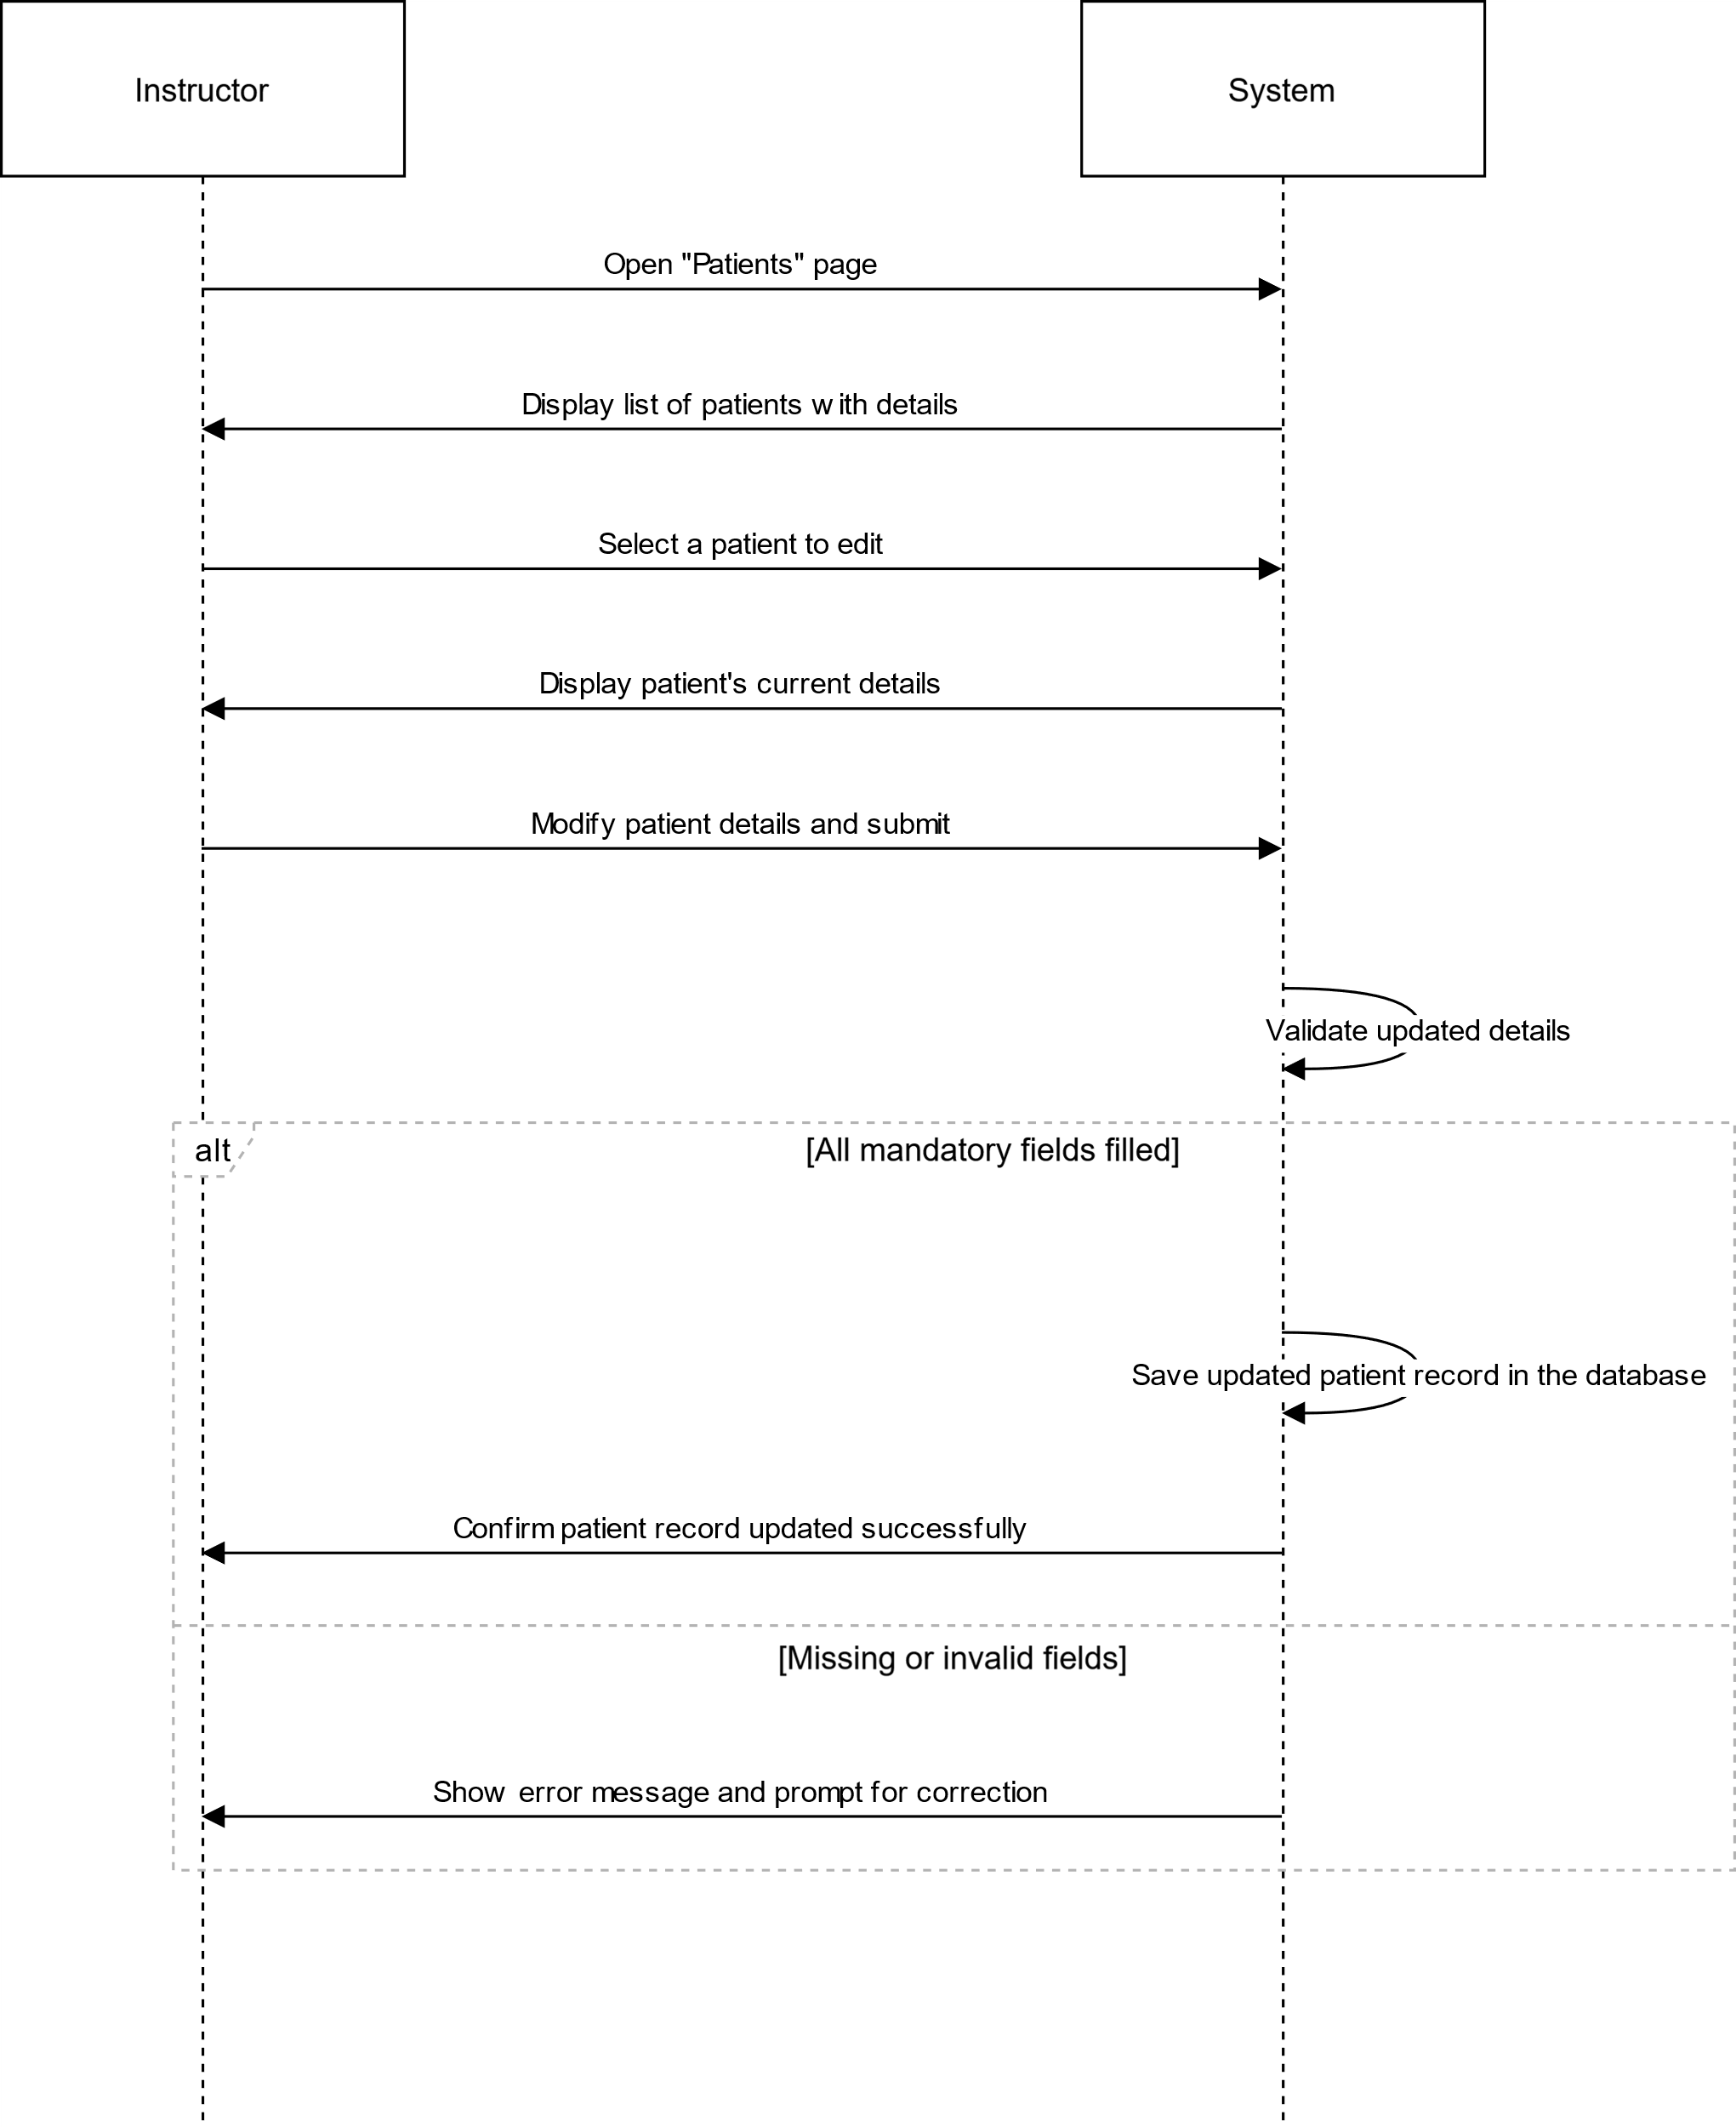

# DOCUMENT REVISIONS

|  |  |  |  |
| --- | --- | --- | --- |
| NUMBER | DATE | DESCRIPTION | RESOURCE(S) |
| 1.0 | March 17, 2025 | Initial Draft | Rinel Mihalcea  Neil Mannion |
|  |  |  |  |

# DOCUMENT REVIEW

|  |  |  |
| --- | --- | --- |
| REVISION NUMBER | DATE | RESOURCE(S) |
| 1.0 |  | Valerie |
|  |  |  |